BOREHAM NEIGHBOURHOOD DEVELOPMENT PLAN FOR THE PERIOD
2025 – 2041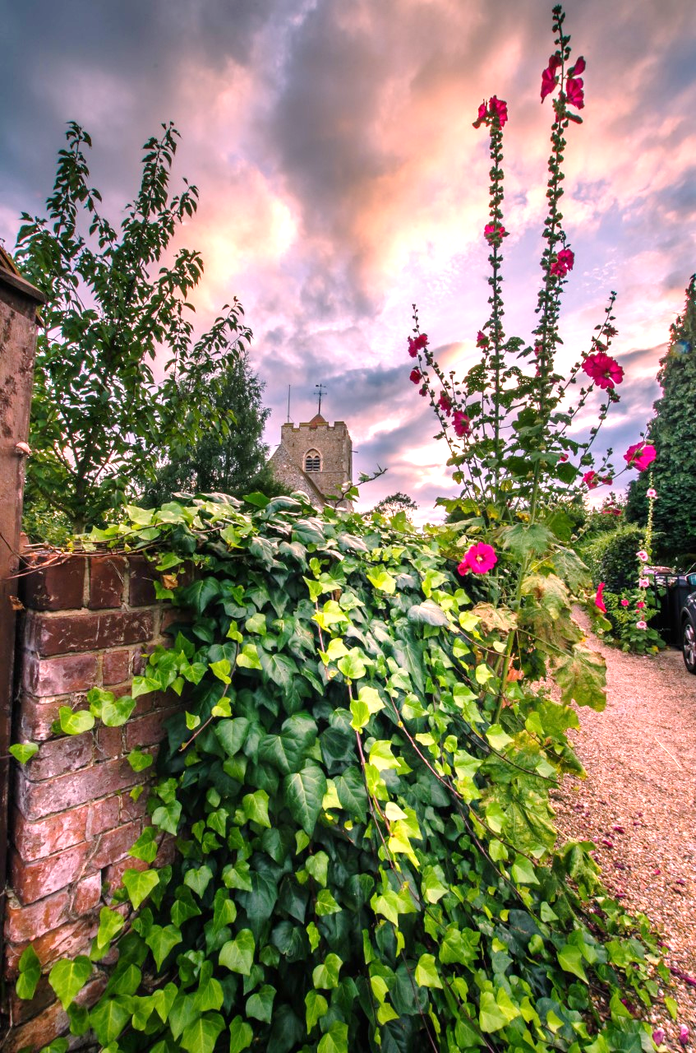
Contents
1. SUMMARY OF THE BOREHAM NEIGHBOURHOOD DEVELOPMENT PLAN 5
2. INTRODUCTION 7
2.1 Context 7
2.2 Neighbourhood Planning 8
2.3 Production of the Boreham Neighbourhood Plan 9
3. ABOUT BOREHAM PARISH 12
3.1 Boreham Parish Boundary 12
3.2 Key Statistics 14
3.3 History & Heritage 14
3.4 Natural Environment 18
3.5 Landscape Character 22
3.6 Drainage and Flooding 23
3.7 Community & Leisure Facilities 24
3.8 Transport (Moving Around) 29
3.9 Housing 33
3.9.1 The Village Centre 35
3.9.2 Main Road 36
3.9.3 Church Road 37
3.9.4 Plantation Road 38
3.10 Business/Local Economy 39
3.11 SWOT Analysis 42
4. VISION & OBJECTIVES 43
4.1 Vision Statement 43
4.2 Summary of Objectives 43
4.2.1 HISTORIC ENVIRONMENT 43
4.2.2 NATURAL ENVIRONMENT 44
4.2.3 LANDSCAPE CHARACTER 44
4.2.4 BUILT ENVIRONMENT 45
4.2.5 COMMUNITY AND LEISURE 45
4.2.6 BUSINESS AND ECONOMY 46
4.2.7 ACCESS AND MOVEMENT 46
5. POLICIES 47
5.1 Historic Environment Policy 47
Policy 1 Heritage 47
5.2 Natural Environment Policies 49
5.2.1 Biodiversity 49
Policy 2 Biodiversity 51
5.2.2 Landscape setting, character, and the protection of high quality agricultural land 52
Policy 3 Landscape Setting, Character, and the Protection of High Quality Agricultural Land 53
5.3 Built Environment Policies 55
5.3.1 Defined Settlement Boundary 55
Policy 4 Settlement Boundary 58
5.3.2 High Quality Design 58
Policy 5 High Quality Design 59
5.3.3 Housing Mix and Type 60
Policy 6 Housing Mix and Type 61
5.4 Community Infrastructure and Developer Contributions Policy 61
Policy 7 Community Infrastructure and Developer Contributions 64
5.5 Broadband and Communication 66
Policy 8 Broadband and Communication 66
5.6 ACCESS AND MOVING AROUND 68
5.6.1 Sustainable Transport 68
Policy 9 Sustainable Transport 70
5.6.2 Main Road and other roads in Boreham 71
Policy 10 Main Road and other roads in Boreham 73
6 ACTION PLAN 75
ABBREVIATIONS 76
APPENDIX 1 LISTED BUILDINGS IN BOREHAM PARISH 77
APPENDIX 2 PUBLIC RIGHTS OF WAY 79
APPENDIX 3 SUGGESTED PLANT LIST FOR DEVELOPERS 80
APPENDIX 4 LIST OF EVIDENCE BASE DOCUMENTS 82

List of Policies
Policy 1 Heritage
Policy 2 Biodiversity
Policy 3 Landscape Setting, Character, and the Protection of High Quality Agricultural Land
Policy 4 Settlement Boundary
Policy 5 High Quality Design
Policy 6 Housing Mix and Type
Policy 7 Community Infrastructure and Developer Contributions
Policy 8 Broadband and Communication
Policy 9 Sustainable Transport
Policy 10 Main Road and other roads in Boreham
List of Tables
Table 3.1 Statistics for Boreham Parish 15
Table 3.2 The identified strengths, weaknesses, opportunities and threats facing Boreham…………….42
Table 5.1 Local Infrastructure Projects which would benefit from developer contributions………….….65
Table 6.1 Action Plan to be commenced on adoption of the BNDP…………………………………………………..75

SUMMARY OF THE BOREHAM NEIGHBOURHOOD DEVELOPMENT PLAN
Boreham is a rural village with a long history. It was sited alongside a Roman road which has, over the ages, brought a steady stream of travellers to Boreham as they journey from London to Colchester and destinations between and beyond. Until the 20th Century, agriculture was the main source of income for Boreham families and the village is surrounded by fields. To the south, it is bounded by the River Chelmer, to the north and west, fields separate Boreham from Chelmsford and Springfield and to the south and east, fields separate Boreham from its neighbouring villages of Hatfield Peverel and Little Baddow.
Over the years, the Roman road, now Main Road, developed into a major thoroughfare and was part of the A12 until the Springfield Boreham by pass opened and the A12 was rerouted in 1971. Main Road effectively bisects the village and the level of traffic through Boreham continues to be a major concern to residents. There is also a strong desire to promote active travel within and beyond the village and to reduce the level of traffic on the main roads through the village.
There is little desire to increase Boreham beyond the existing Defined Settlement Boundary and strong support for maintaining the separation of our village from its neighbours and protecting the rural nature of the village. Over the years, agriculture has been replaced as the primary source of income. Easy access to London via the railway network means that many residents commute there for work. There are a number of small and medium sized businesses operating in the village and the historic roadside inns continue to operate as pubs, inns and restaurants bringing revenue into Boreham. The proliferation of local businesses drives demand for high speed broadband and reliable communication networks.
Residents have identified the need for additional green space and local community amenities with particular emphasis on early years (nursery) school places, activities for older children and access to GPs. In addition, there is strong support for protecting conservation areas within the parish and other heritage assets. There is also concern regarding the loss of biodiversity within our parish. There are local efforts to reverse this loss.
The purpose of the Boreham Neighbourhood Development Plan (the Plan) is to deliver policies which support the stated objectives of Boreham residents.
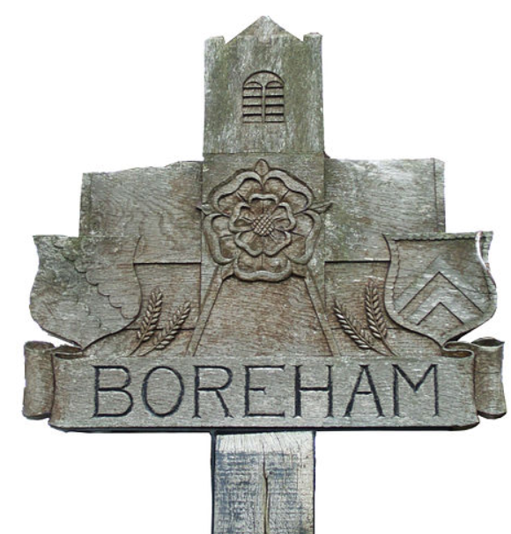
Figure 1.1 The Boreham village sign reflecting links to the Boleyn family and Henry VIII, St Andrew’s Church, the rural nature of the parish and the heraldic shields of the Earls of Sussex on the left hand side (the Radcliffe coat of arms) and the Tyrell family (Tyrell coat of arms) on the right.

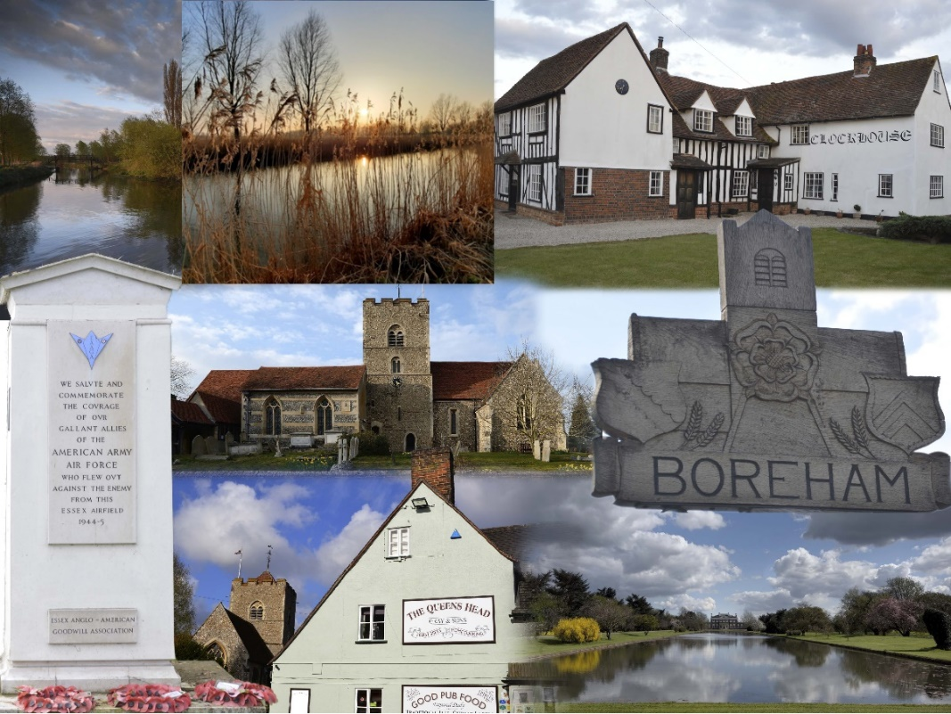

Figure 1.2 A collage of Boreham landmarks from top left clockwise 2 views of the canalised River Chelmer, The Clockhouse, Main Road, the Boreham village sign, Boreham House lake, the Queen’s Head public house, Boreham Airfield War Memorial and St. Andrew’s Church (centre).

INTRODUCTION

Context
The Boreham Neighbourhood Development Plan (BNDP) presents a vision for the sustainable evolution of Boreham Parish for a term of 15 years from its adoption. It covers a wide range of issues that will influence the well-being, sustainability and long-term conservation and improvement of this thriving rural community. The community and key stakeholders have been extensively consulted to ensure that the contents of this document are a true representation of local community views.
The planning context is provided by the National Planning Policy Framework December 2024 (NPPF), National Planning Policy Guidance, Chelmsford Local Plan and the Village Design Statement. Neighbourhood planning is a concept which has been around for some time, and was given concrete expression in the Localism Act 2011. It is now an established part of the planning process. The Act allows local communities to prepare Neighbourhood Development Plans (NDPs) to help shape planning arrangements for their local area. Planning Practice Guidance states:-
“Neighbourhood planning gives communities direct power to develop a shared vision for their neighbourhood and shape the development and growth of their local area. They are able to choose where they want new homes, shops and offices to be built, have their say on what those new buildings should look like and what infrastructure should be provided, and grant planning permission for the new buildings they want to see go ahead.”
In 2016 Boreham Parish Council (BPC) notified Chelmsford City Council (CCC) of its intention to produce an NDP. As the Qualifying Body, BPC is responsible for the preparation and monitoring of the Boreham Neighbourhood Development Plan (BNDP/the Plan). In 2022 CCC approved the revised BPC Parish boundary as the Designated Area (referred to as ‘the Parish’ in the remainder of this document and outlined on the map in Figure 3.2) for the BNDP. It is within this new boundary area that the plan and policies applies.
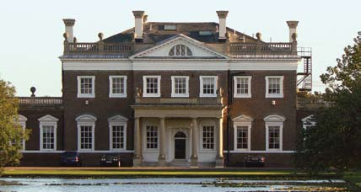
Figure 2.1 Boreham House is a grade 1 listed building on the western edge of Boreham village and its grounds are a Registered Park and Garden

Neighbourhood Planning
The BNDP is part of the wider planning context for the area, most notably the Chelmsford Local Plan, the adopted Essex Minerals Local Plan (2014) (MLP) and the adopted Essex and Southend-on-Sea Waste Local Plan (2017) (WLP).
The primary purpose of Neighbourhood Planning is set out by the National Planning Policy Framework (NPPF) paragraph 58, which states:
“Local and neighbourhood plans should develop robust and comprehensive policies that set out the quality of development that will be expected for the area. Such policies should be based on stated objectives for the future of the area and an understanding and evaluation of its defining characteristics.”
The NPPF (paragraph 135) states that: “Planning policies and decisions should aim to ensure that developments:
- will function well and add to the overall quality of the area, not just for the short term but over the lifetime of the development;
- are visually attractive as a result of good architecture, layout and appropriate and effective landscaping;
- are sympathetic to local character and history, including the surrounding built environment and landscape setting, while not preventing or discouraging appropriate innovation or change (such as increased densities);
- establish or maintain a strong sense of place, using the arrangement of streets, spaces, building types and materials to create attractive, welcoming and distinctive places to live, work and visit;
- optimise the potential of the site to accommodate and sustain an appropriate amount and mix of development (including green and other public space) and support local facilities and transport networks; and
- create places that are safe, inclusive and accessible and which promote health and well-being, with a high standard of amenity for existing and future users; and where crime and disorder, and the fear of crime, do not undermine the quality of life or community cohesion and resilience.”
The Plan provides a framework to manage development in the area for residents, businesses, BPC, CCC and the development industry. Adopted by CCC on 3rd August 2026, the Plan is now a statutory document which will be used alongside National Policy and will be formally integrated into CCC’s Local Plan and used to determine planning applications in the Parish.

Production of the Boreham Neighbourhood Plan
A steering group was formed open to those who lived, worked and did business in the area, to draft the plan and engage with the community. The key areas covered in this resulting plan are:
• History and Heritage
• Natural Environment
• Community and Leisure Facilities
• Transport (Moving Around)
• Housing
• Business/Local Economy

The information and data that has guided and influenced this plan has been assimilated and collated on a voluntary basis by the Steering Group. Views of local residents have been obtained by way of a survey questionnaire, public events and written contributions.
Over 300 people responded to the Boreham Neighbourhood Plan Questionnaire (the Questionnaire). Overwhelming support was expressed for the following (300 or more responses):
• A green buffer with Chelmsford to mitigate coalescence
• The natural environment plays a key role in defining Boreham’s character and enhancing quality of life
• The protection of the Recreation ground, Chase field and other green spaces within the village
• Opposition to further large scale development after the allocation of land east of Plantation Road in the 2021 Chelmsford Local Plan

Strong support was expressed for the following (between 250 and 299 responses):
• The historic environment; historic buildings, ancient hedges and other historic features play a key role in defining Boreham’s character and enhancing quality of life
• Gardens are important for nature conservation and the character of the village
• Measures should be taken to reduce noise impact from the A12
• The Defined Settlement Boundary extended to include the recent Bloor Homes development (Orchard Way), should not be breached by new development
• All new developments should make provision for sufficient off street parking
• New development should be carried out in a manner to avoid potential security and vandalism problems
A majority support small-scale development of under 6 dwellings and on existing sites in the village. Strong opposition was expressed against the development of executive housing and social housing. Support was expressed for rented, first time buyer/low cost, private, sheltered and family housing.
In terms of community facilities and wellbeing, a majority of respondents considered that the churches, village, pubs and post office were adequate, while a majority considered the surgery and facilities for young people were inadequate.
Questionnaire responses have guided the drafting of the BNDP by providing the Steering Group with an understanding of local residents view on key issues for the Parish. The Questionnaire was used to help inform the draft BNDP vision, objectives and policy ideas.
Open Day events were held in the Village Hall on 21st September 2017 and the parish wide questionnaire, summarised above, was sent out September 2019 and completed in February 2020. A further consultation event with display commenced on June 2nd 2022 at the Boreham Platinum Jubilee event and continued until 9th July 2022. Local organisations and businesses have been consulted and invited to respond to the questionnaire and/or submissions in writing.
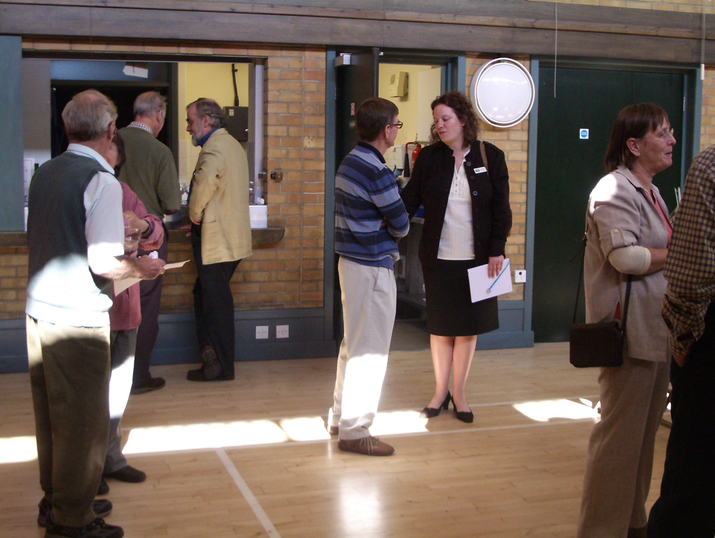

Figure 2.2 Discussions at one of the open day events in 2017

During the development of this document the Parish Council, Chelmsford City Council and the Rural Community Council of Essex (RCCE) have been consulted and other organisations have provided professional advice, guidance and input. We have received grant funding from RCCE.
The Neighbourhood Plan sets out to:
- Identify the main characteristics and community issues for Boreham Parish
- Provide the community’s objectives and policies for the management of development
- Provide an Action Plan listing the desired projects arising from the residents’ vision for sustainable growth in the Parish.

It will be necessary for the Neighbourhood Plan Steering Group to monitor and review the Boreham Neighbourhood Development Plan throughout its term to consider any changes to the adopted Chelmsford Local Plan or relevant legislation and to ensure that it remains fit for purpose.
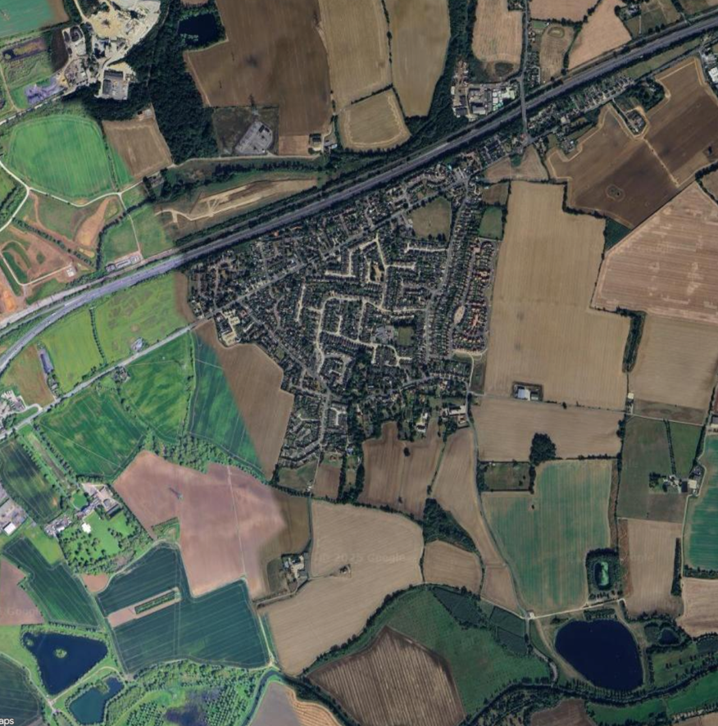
Figure 2.3 The village of Boreham set in the Essex countryside (Google Maps – satellite)

ABOUT BOREHAM PARISH

Boreham Parish Boundary
The Parish of Boreham covered an area of approximately 6 square miles. The boundary of Boreham Parish is presented in figures 3.1 and 3.2 below.

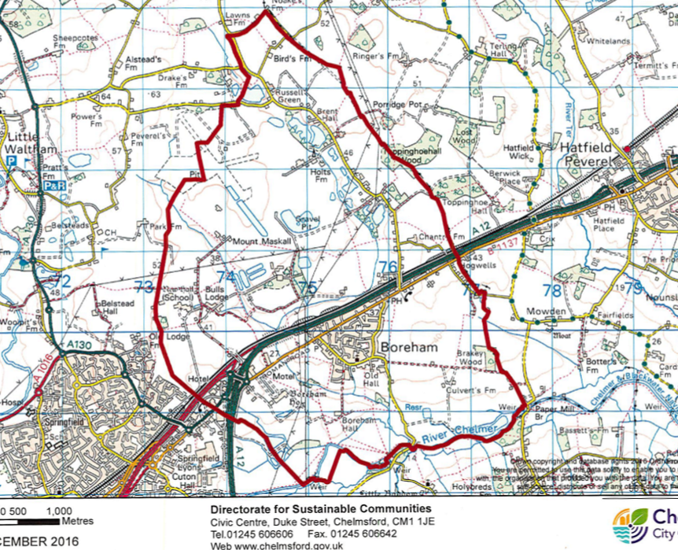
Figure 3.1 Boreham Parish Boundary until 2022
CCC undertook a Community Governance Review in 2022, to evaluate parish boundaries to take account of new and proposed housing developments. The main change was removing the area to the north-west of the parish (including part of Boreham Airfield) to form part of the new Chelmsford Garden Community Parish. The resulting, current Parish boundary is shown in Figure 3.2.

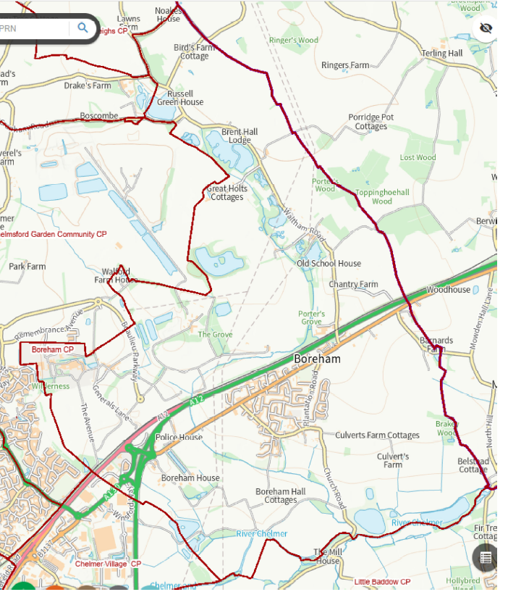
Figure 3.2 Boreham Parish Boundary following the 2022 revision

Key Statistics
Key statistics relating to Boreham Parish are set out in table 3.1. The table describes the key characteristics of the population of the village and how we live. A comparison with 2011 census data confirms that the Parish population has increased by 10% to 3,970 from 3,597 in 2011. This reflects an increase in the number of households in the village from 1,515 from the 2011 census to 1,600 in the 2021 census data.
Population |  | Source
Total | 3970 | 2021 Census
Aged under 20 | 25.4% | 2021 Census
Aged 20 to 60 | 50.2% | 2021 Census
Aged over 60 | 24.4% | 2021 Census
People per hectare | 1667 | Calculated
People working from home (employed 16yrs+) | 34.6% | 2021 Census
Economically Active (16yrs+) | 63.9% | 2021 Census
Households
Total households | 1600 | 2021 Census
Single person households | 29.2% (466) | 2021 Census
Social Housing | 16.8% | 2011 Census
Planning consents unbuilt | 17 | CCC Planning 2/10/2023
Persons per house | 2.5 | 2021 Census
Housing type
Flat/Maisonette/Apartment | 13.2% (211) | 2021 Census
Bungalow/Whole House | 86.7% (1387) | 2021 Census
Mobile structure (caravan/houseboat) | 0.1% (2) | 2021 Census
Transport
Households with no car | 10.8% (173) | 2021 Census
Households with one car | 39% (624) | 2021 Census
Households with 2 or more cars | 50.2% (803) | 2021 Census
Travel < 6.2 miles (10km) to work | 28.8% | 2021 Census
Travel 6.2 miles (10km) to < 18.6 miles (30km) to work | 13.6% | 2021 Census
Travel > 15 miles (24.1km) to work | 6.4% | 2021 Census
Nearest hospital | Broomfield
Nearest GP | In village
Nearest secondary school | Beaulieu Park School
Table 3.1 Statistics for Boreham Parish

The proportion of detached homes in the Parish (45%) is higher than the national average of 22.5% with the majority of housing being owner occupied (73%) of households. There is a higher than average car ownership in Boreham (89.2% of households according to the 2021 Census).

History & Heritage
The following summary highlights some key features of the historic environment of Boreham parish a more comprehensive, fully referenced, account is provided by EB1 Boreham Parish: historic environment characterisation in the evidence base.
The origins of human inhabitation of Boreham parish lie deep in prehistory and there is considerable evidence of Neolithic and Bronze Age settlement, including a Late Bronze Age metal hoard and cremation cemetery to the west of the modern village, evidence for Iron Age settlement is also widespread. In the Roman period the area lay on the road from London through Chelmsford to Colchester, the modern Main Road follows the line of the Roman road. A villa and apsidal building, possibly a temple or administrative building for a rural estate, have been excavated in the north of the parish. Settlement continued into the Saxon and medieval period.
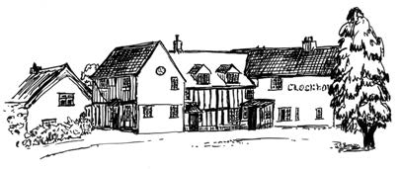
Figure 3.3 A sketch of the Clockhouse in one of Boreham’s conservation areas.
Throughout this long period of time, settlement in Boreham was dispersed. The Chapman and Andre map of 1777 essentially shows the settlement pattern which had been established during the medieval period, with individual farms and manorial centres spread across the parish with a few small clusters of buildings at focal points such as significant road junctions and around the church. Two of these clusters, one around the church and the other at the junction of Plantation Road and Main Road are now conservation areas. A number of older properties, many listed (see Appendix 1), at these locations and scattered throughout the parish, reflect this historically dispersed settlement pattern.
The large grade 1 listed parish church was a key focal point, the oldest parts of the building date from the Saxon period, additions and alterations throughout the medieval and post medieval periods have created the building as it is today. The diverse landscape of the parish from the boulder clay plateau to the damp pasture of the Chelmer valley was a key resource. Woods and hedges frequently thought of as natural features, are human creations often of great antiquity, indeed next to the church as in most parishes, they are likely to be the oldest easily visible remains of human activity. In Boreham, some field boundaries have been shown to originate in the Roman period and possibly even earlier.
Boreham was a largely self-contained rural community, but always, from remote prehistory onward, had a range of interactions with the wider world. The river Chelmer has, since prehistoric times, been a major routeway to the wider world, something which was formalised in the late 18th century by the creation of the Chelmer and Blackwater Navigation, the length of which, including the portion in Boreham Parish, is now a conservation area.

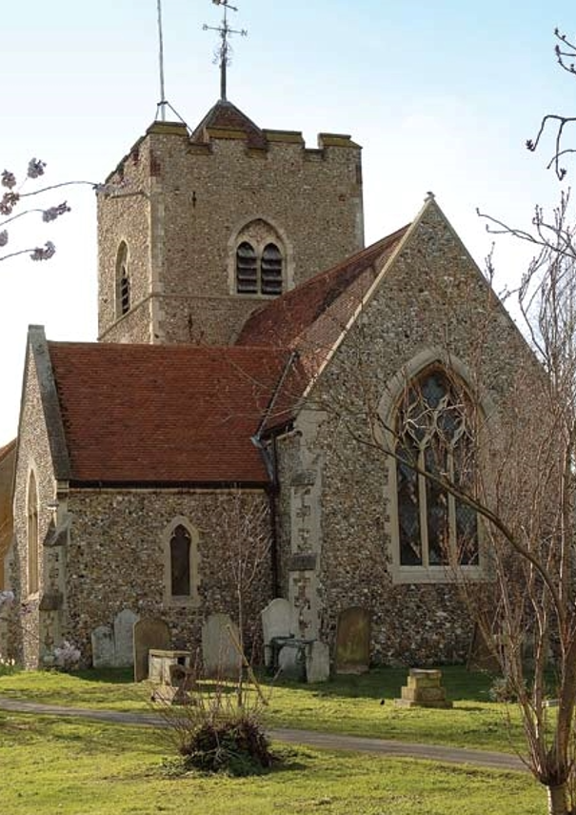
Figure 3.4 St Andrew’s Church from the east
The attractiveness of the landscape and relative ease of access to London, led to the construction of New Hall in the 16th century and Boreham House in the 18th century, both grade 1 Listed buildings. These buildings and their associated parks and gardens transformed large parts of the western side of the parish. New Hall was owned by some of the most prominent and powerful people in 16th and 17th century England, and brought considerable wealth to the parish, as evidenced by the monumental tomb of the Radcliffe Earls of Sussex in the Church. In the 19th and early 20th century the economy was still largely agricultural with a mix of arable, pasture and orchards, but with a forge, butchers, shops, public houses and a school to support the community and provide local employment.
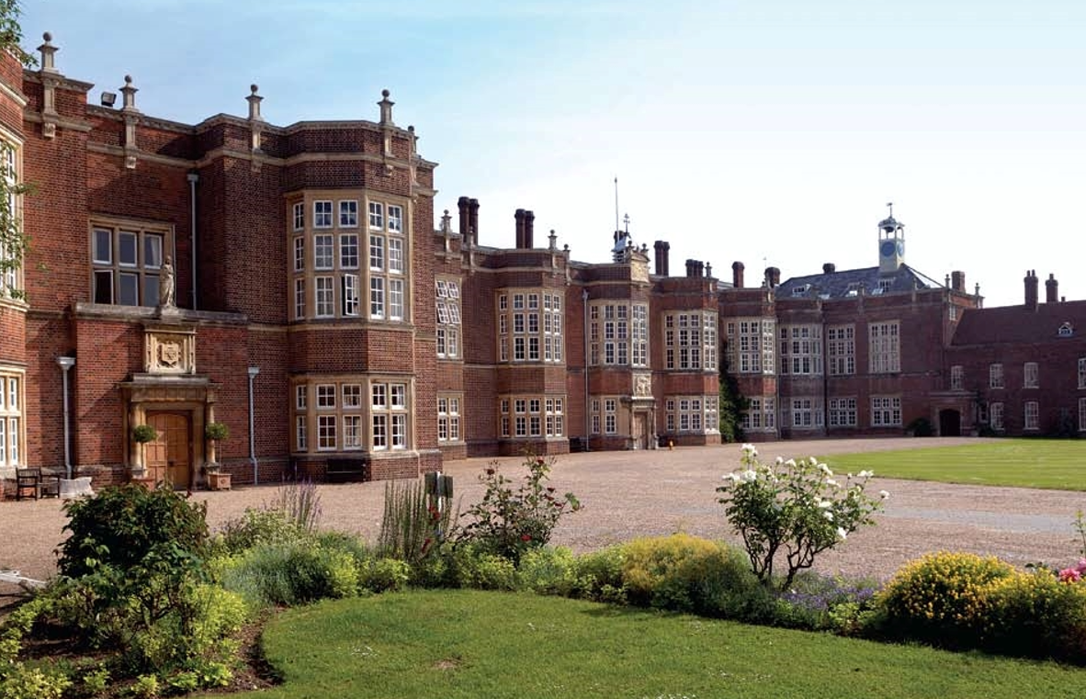
Figure 3.5 New Hall, formerly owned by Thomas Boleyn and Henry VIII is now a private school
The Second World War brought major changes notably, in 1943, the construction of a large airfield in the northern part of the parish. One of many constructed across Essex, Boreham airfield was used as a base for medium bombers of the US Army Air force. After the war, the airfields buildings were used as temporary housing and the airfield perimeter track for motor racing. More recently the airfield has been used as a base for the police helicopter and extensive quarrying for sand and gravel has removed a large part of the former airfield. A major part of Boreham Airfield is now part of Chelmsford Garden Community Parish but some still remains in Boreham Parish. As part of the Hanson agreement, all of the gravel extraction site was to be returned as a country park not just the area in the north next to the new Garden Community Parish.
In the second half of the 20th century a succession of housing developments created a strongly defined nucleated village south of the A12 around the loop of roads formed by Main Road, Church Road and Plantation Road. Whilst many people now commute for work to Chelmsford, other local towns, and London, the village supports shops, pubs and other businesses.
Boreham remains a separate village, surrounded by agricultural land and open countryside, much appreciated by residents. It has an individual identity distinguishable from the urban expansion of Chelmsford and outstanding views to the south over the Chelmer Valley. There are various Grade II Listed Buildings located within the Defined Settlement Boundary and in the wider Parish. Remnants of the architectural styles and building materials such as timber framing with pastel coloured render, red brick and red clay roofing tiles can be seen on the older buildings within the Parish. The village has a strong sense of community and identity and good communication links with the rest of Essex. The Defined Settlement Boundary is approximately triangular in shape formed by A12, Church Road and Plantation Road. The traffic noise from the A12 is intense and Main Road, Plantation Road, Waltham Road and Church Road are frequently used as “rat runs” for through traffic.
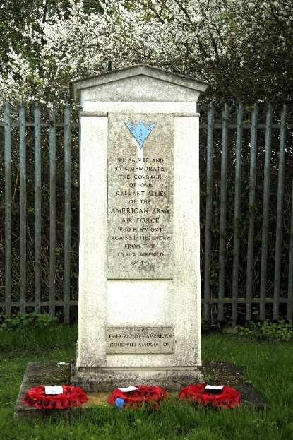 Figure 3.6 Boreham Airfield war memorial
Boreham’s community spirit has been retained throughout all these changes, fostered by the church, numerous village organisations, the school, local sports clubs and many clubs meeting in the village and events such as Boreham in Bloom and the local village show.

Natural Environment
Boreham Parish falls largely across the Lower Chelmer Valley and Boreham Farmland Plateau. The Chelmer Valley is strongly associated with the work of J. A Baker and particularly his book ‘The Peregrine’ and it is increasingly seen as one of this country’s key literary landscapes and a site of cultural value. The landscape is rural and much of the area is used for arable farming.
There are 6 recognised Local Wildlife Sites (LoWS) either wholly or partially in Boreham Parish: The Grove, Boreham Road Gravel Pits, Boreham Meads, Bulls Lodge Lagoons and Toppinghoehall Wood, ancient woodland (partly in Boreham and partly in Hatfield Peverel parish). The LoWS include ancient woodland, streamside woodland, lakes and wetlands and provide varied habitats which support significant biodiversity. Whilst none of the habitat components at Bull’s Lodge Lagoons (reedbed, willow scrub, ‘brownfield land’, eutrophic lakes) is of exceptional size or quality, in combination they comprise an intricate and varied habitat mosaic that is capable of supporting a very wide range of flora and fauna.
Many of these sites are now privately owned and some are used for recreational activities such as hunting and fishing. Another privately held site of interest is Brakey Wood. This wood is not designated as ancient but it has a structure and composition that indicates an ancient status. The far north-western corner of the wood has many young wild service-trees (Sorbus torminalis). Ground flora species indicative of ancient woodland such as early purple orchid (Orchis mascula), Wood Spurge (Euphorbia amygdaloides), moschatel (Adoxa moschatellina), goldilocks buttercup (Ranunculus auricomus), wood-sedge (Carex sylvatica), primrose (Primula vulgaris) and wood speedwell (Veronica montana) are all found there. Curiously, the local authority boundary cuts across the north-east corner, so that this undefined part of the wood is a Braintree LoWS (Bra99). Unfortunately, these sites are becoming increasingly fragmented and are, in many cases, declining due to climate change, neglect and/or inadequate management and control of more invasive species.
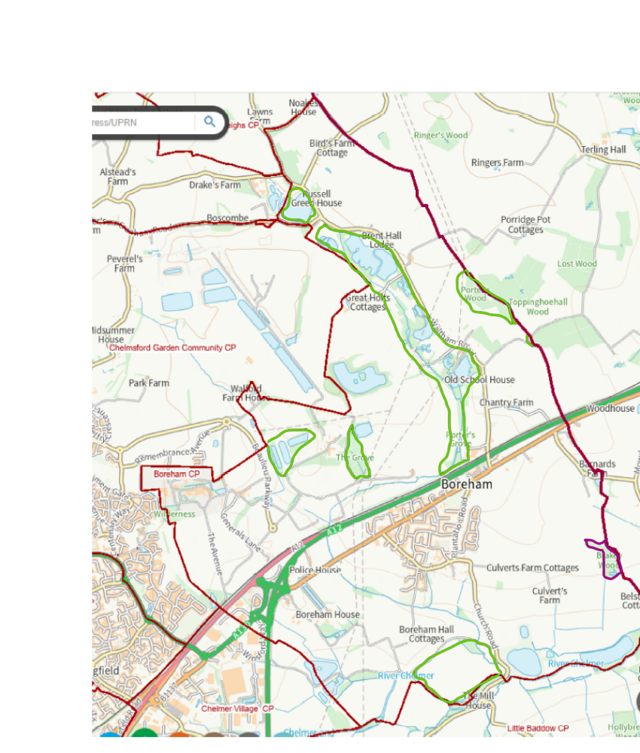
55
22
22
44
11
33
66
5511
Figure 3.7: Showing the location of the local wildlife sites and Brakey Wood as follows. Local wildlife sites outlined in green: 1. RCLWS Ch107 The Grove, Boreham (5.82 ha) TL 74891059 2. RCLWS Ch113 Boreham Road Gravel Pits, Boreham (23.45 ha) TL 75631161 3. RCLWS Ch125 Boreham Meads, Boreham (23.86 ha) TL 767008644. RCLWS Ch176 Bulls Lodge Lagoons, Boreham (10.69 ha) TL 742910685. RCLWS Ch116 Porter’s/Toppinghoehall Woods, Boreham (part of) (6.38 ha) TL 76081207 and RCLWS Ch120 Toppinghoehall Wood, Boreham (part of) (0.3 ha) TL 76531165 and 6. RCLWS Ch128 Brakey Wood, Boreham (part of) (4.52 ha) TL 77210965 outlined in purple. Refer to EB2 Natural Environment in the evidence base for additional information.
Boreham’s natural environment is an integral part of a wider landscape and other significant elements include streams, most notably Boreham Brook, small ponds and agricultural reservoirs, willow plantations, small woods and hedgerows. Hedgerows and boundaries are often of ancient origin and form a key habitat. Also important to biodiversity are the large grounds around the Grade 1 listed buildings at Boreham House and New Hall in combination with smaller gardens and open spaces throughout the village. The parish also contains wet woodland (a Habitat of Principal Importance in England) which supports diverse invertebrates and breeding and feeding birds. Areas of bare ground left by quarrying activities are also of value as important habitat for many invertebrates.
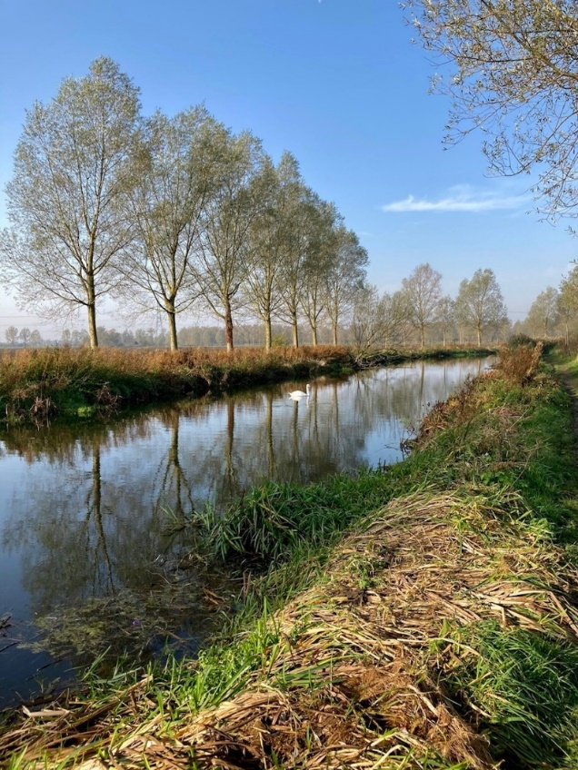
Figure 3.8 The River Chelmer at Boreham Photograph courtesy of Liz Chapman
Within the parish we have some examples of fairly rare species such as a small colony of Southern Marsh-orchid (Dactylorhiza praetermissa), an Essex Red Data List (ERDL) species and wild service-tree (Sorbus torminalis) which is now relatively rare and is associated with ancient woodland. Boreham Meads along the River Chelmer in the south of the parish has two other ERDL species present which are Large Bitter-cress (Cardamine amara) and Brown Sedge (Carex disticha). In 2017, a very rare nesting summer visitor, tree pipits set up a territory here (Red-listed for the UK and Essex). On the north side of the Chelmer there is also a large block of grassland where ERDL species Meadow Saxifrage (Saxifraga granulata) has been reported. The adjacent Boreham Special Roadside Verge has specimens of Common Meadow-rue (Thalictrum flavum), a rare Essex plant that is also included on the ERDL.
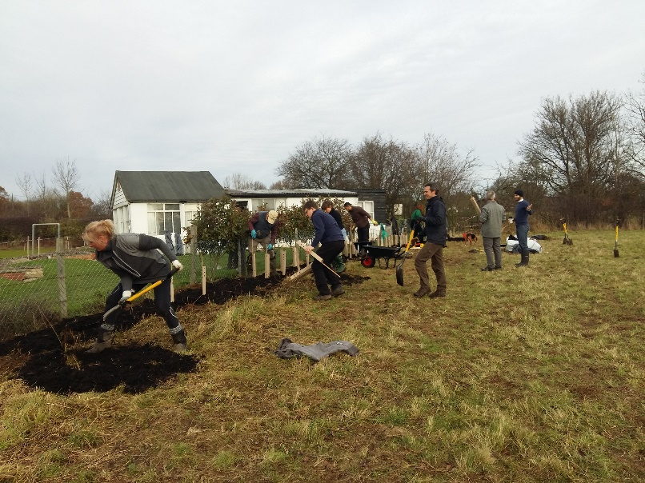
Figure 3.9 Volunteers planting new hedgerow
With the recent focus on climate change and biodiversity loss, the need to protect our natural environment is moving up the collective agenda and galvanising volunteer groups in the parish to take action to foster greater biodiversity. Boreham Parish Council (BPC) owns a 5 acre field in the parish and in 2021 this was allocated for development as a small, local nature reserve. It is being managed by BPC Climate Crisis Environmental Working Party and other volunteers. Initial activities have included hedgerow planting, tree planting, the creation of a pond and other projects to help improve our declining, natural environment. The project has been supported by an Essex County Council (ECC) locality fund grant, the ECC Climate Challenge Prize Fund and by the Essex Forest Initiative.
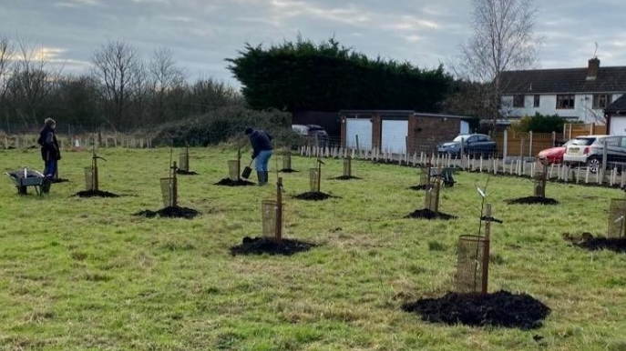
Figure 3.10 The start of the Seabrook Heritage community orchard at Chantry Field

Landscape Character
Boreham remains a separate village, surrounded by agricultural land, much of it of good quality, and open countryside, much appreciated by residents. The clear separation of Boreham village from the urban edge of Chelmsford is fundamental to Boreham's landscape setting and character.
The northern part of Boreham Parish lies on the Boulder clay plateau of central Essex. The north west part has been affected by construction of a WWII airfield and subsequent gravel extraction and much of the north and west of this area has been removed from Boreham parish. The western part of the landscape is dominated by the Grade I listed New Hall school and its associated registered park and gardens. Immediately west of Waltham Road, in an area historically mostly pasture along the upper reaches of the Boreham/Bulls Lodge Brook, gravel extraction and subsequent restoration has created a distinctive landscape of ponds, lakes, small woods, and grassland. On the eastern side of Waltham Road, there is an area of arable and pasture fields with woods on the eastern boundary of the parish. The lanes, tracks and field paths are integral parts of the network of routeways connecting the historically dispersed settlement pattern. The historic field boundaries survive relatively well in this area, remarkably field boundaries around Chantry Farm include mature elms which have survived elm disease. Much of the north and east of this area will be affected by the Longfield Solar Farm.
In the southern part of the parish, the Chelmer valley landscape provides the physical and visual frame for the nucleated village of Boreham giving it its rural character. In particular, entering or leaving the nucleated village, whether by road or by footpath, the views across fields to distant wooded hills on the south side of the valley provide a distinct rural ambience. The Chelmer Valley is strongly associated with the work of J. A. Baker and particularly his book ‘The Peregrine’ and it is increasingly seen as one of this country’s key literary landscapes and a landscape of significant cultural value.
In Boreham Parish the Chelmer valley is bisected by the valley of the Bulls Lodge, aka Boreham Brook, a locally significant tributary of the Chelmer which is bordered by hedges, the valley slope runs down to the river Chelmer which is bordered by cricket bat willows. Looking west from the village the view is toward the Grade I listed Boreham House and its associated registered park and gardens. The general pattern of historic field boundaries, tracks and paths with scattered groups of buildings, typical of the historic landscape, survives. Fields are largely arable with some pasture and plantations of willow for cricket bats or coppiced for biofuel in the valley bottom. A more detailed description of the Chelmer Valley is provided in EB3 Chelmer Valley Landscape Character in the evidence base.

Drainage and Flooding
The Boreham Defined Settlement Boundary is not prone to significant flooding. Figure 3.11 shows the Environment Agency Flood Mapping for the area and confirms that no properties are in danger of fluvial flooding, although surface water and pluvial flooding may be an issue in a few locations as shown in pale blue on the map. Where flooding does occur, it is in areas primarily impacting local farms and a small stretch of Church Road north of Black’s Bridge. No issues have been identified which would require specific mitigation measures beyond those in the Local Plan and national planning policies.
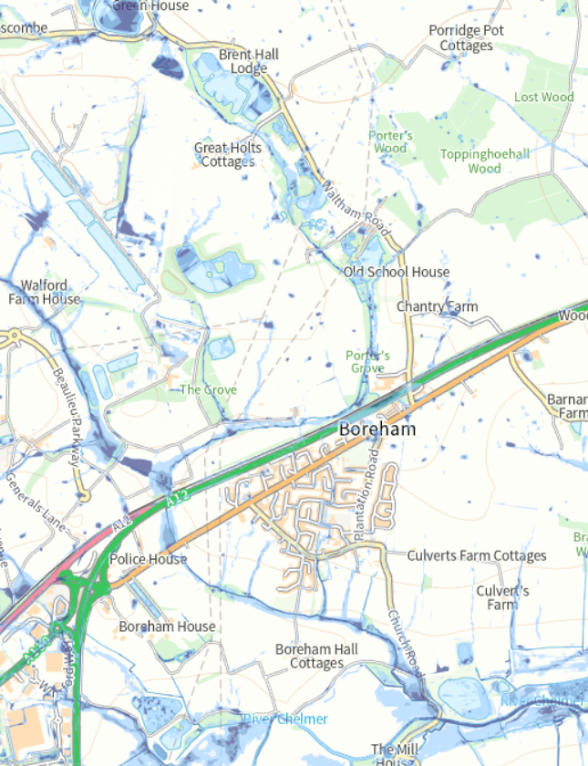
Figure 3.11 Environment Agency (EA) Flood Map for Boreham Parish
The EA flood mapping website is at Flood map for planning - GOV.UK

Community & Leisure Facilities
Boreham is served by a network of footpaths and bridlepaths both within the parish and leading to adjacent parishes (Refer to Appendix 2 – Public Rights of Way). These present opportunities for walking, cycling and horse riding in rural surroundings. There are also cycle paths linking Boreham to Chelmsford and some minor roads and protected lanes (Refer to the Evidence Base EB5: Boreham Protected Lanes) locally offer additional opportunities for walkers and cyclists to explore the local countryside.
The footpath along the Chelmer and Blackwater Navigation covers 14 miles of scenic riverscape from Chelmsford to the estuary at Maldon/Heybridge Basin. The river is becoming increasingly popular as a leisure centre for paddle boarders, canoeists and open water swimmers. Adjacent to the river, Tri Farm, based at an agricultural reservoir, is an open water training centre and running/cycling track for local triathletes open during the summer months. There are also fishing lakes in the north of the parish which are privately owned by various fishing clubs.
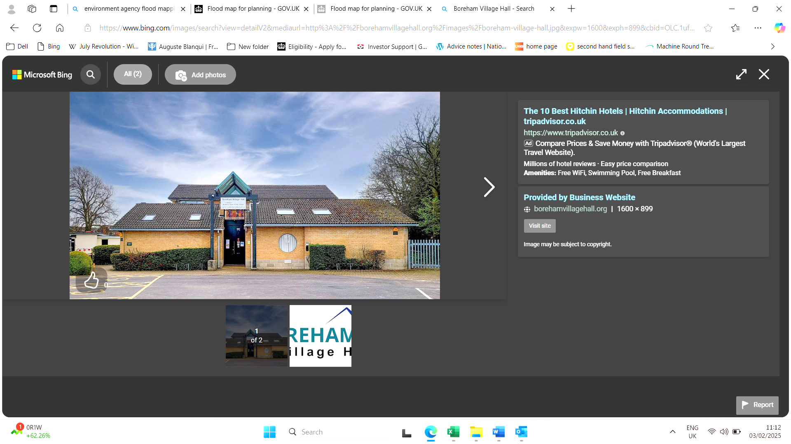
Figure 3.12 Boreham Village Hall
The Village Hall, located in the centre of Boreham is used for local events including Parish meetings, a wide variety of community run clubs, groups and other community events. It is also one of 2 polling stations for elections (general and local). There is a Scout local headquarters next to the Village Hall. Boreham has allotments at Church Field in Waltham Road (administered by the diocese of Chelmsford) and at the Lion Inn (provided by Boreham Parish Council). These allotments are fully subscribed with a waiting list.
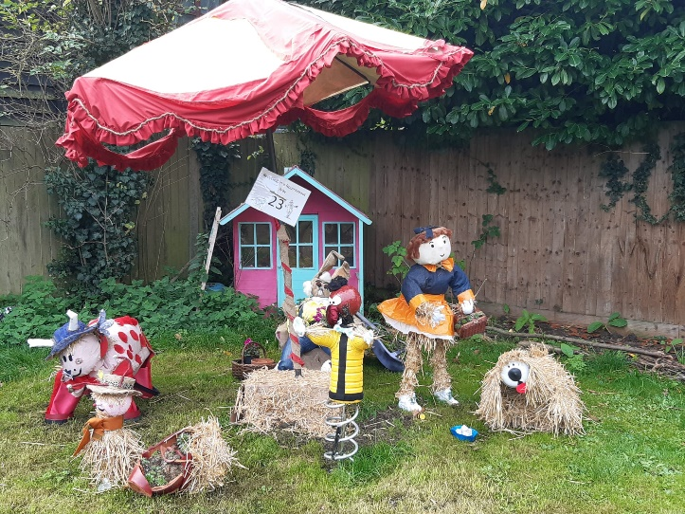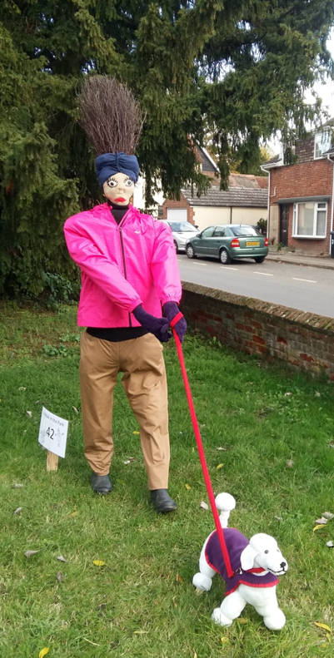
Figure 3.13 The Scarecrow Trail is a village fundraising event
The village’s only church, St Andrew’s, Church of England, is in the centre of the village. It hosts community activities including the Edward Bear babies and toddlers' group and a weekly community coffee morning. The church has a meeting facility, the Pelly Room, which holds events and is the second of the village polling stations. Every two years about 30 private gardens and the church are open for “Boreham In Bloom” which is a church fundraiser. Plans are being formulated to renovate this Grade 1 listed building and make it a resource for the entire community and fund raising is in progress. The church building is set within the village’s only burial ground.
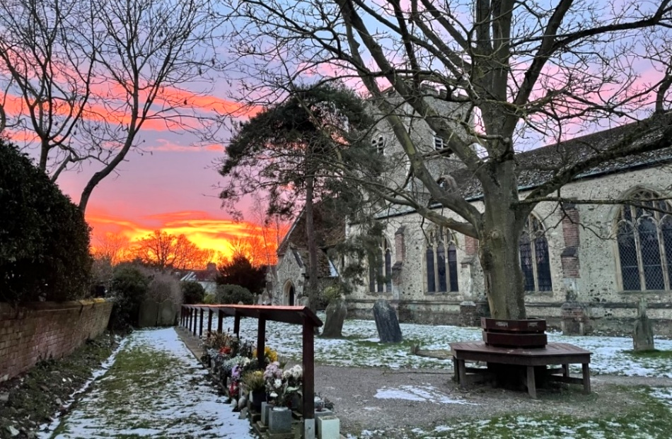
Figure 3.14 St Andrew’s Church – Photograph courtesy of Rev Emma Wiley
The John Galley Memorial Ground, is a recreation ground which includes children’s play equipment and is adjacent to the Village Hall. It is used for outdoor activities year-round. Groups play cricket in the summer and football for the rest of the year. The ground also includes outdoor exercise equipment, a basketball hoop, table tennis table and a sports and social club. It is also used for some village events.
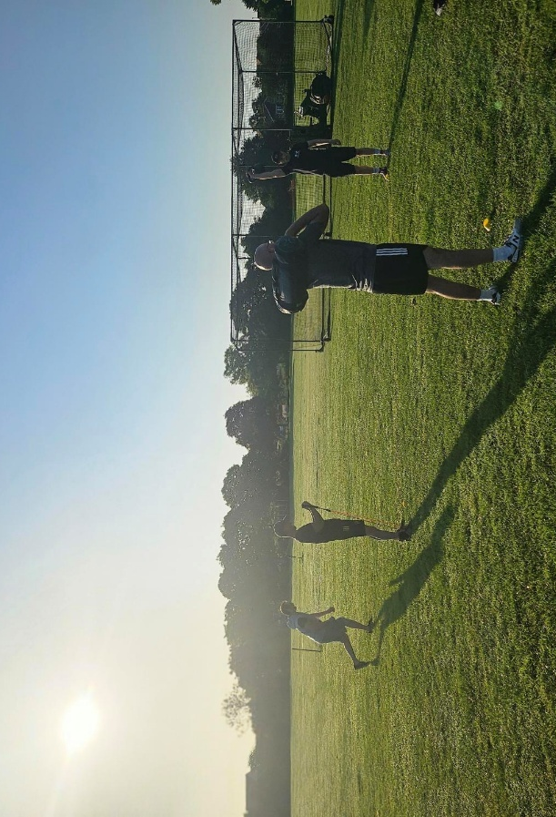
Fig 3.15 A men’s wellness group meets weekly at John Galley Memorial Ground – Photograph courtesy of Phil Whitehead
There is a second field available for use as a play area at Chase field. This is rented from Chelmsford City Council and also contains children’s play equipment and a skateboard practice area. There is also a Bowling Green and clubhouse just north of the village settlement area on Waltham Road. The Parish Council is currently developing Chantry Field, a 5 acre site adjacent to the Bowling Club as a nature reserve and amenity space.
The Chelmsford City Council Open Space Study of December 2024 assesses the supply of green space by parish, including Boreham. This study identifies a deficit of the following green spaces in Boreham Parish:
• Parks and recreation
- Natural and semi-natural
- allotments

The output from this study has helped to identify infrastructure projects for the BNDP and will inform infrastructure related policies as there are no specific plans to address the shortfalls in the Infrastructure Delivery Plan Stage 2: Infrastructure Delivery Plan to Support Regulation 19 for the updated Chelmsford Local Plan dated 11 November 2024.
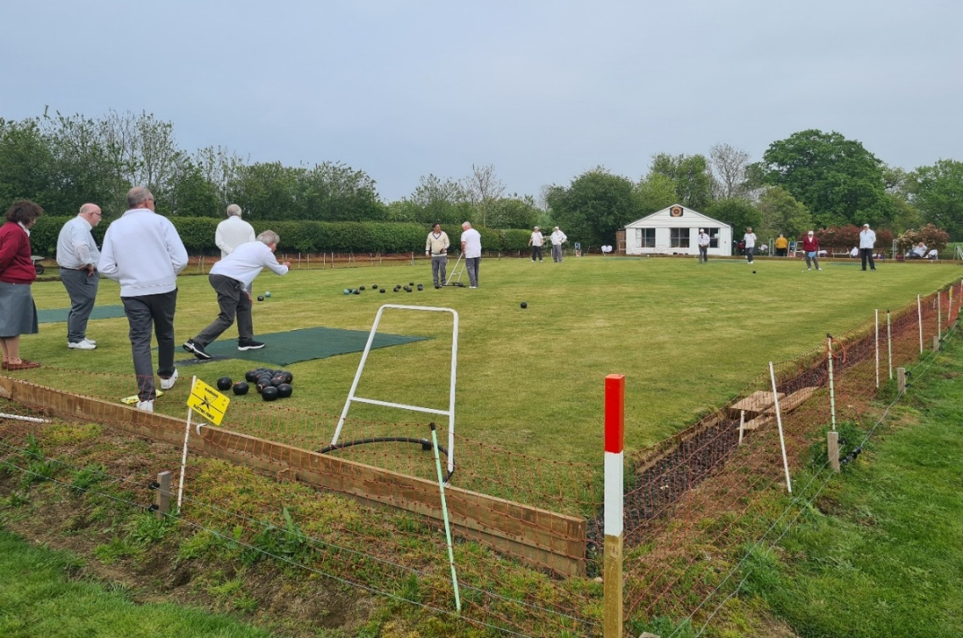
Figure 3.16 A match at Boreham Bowling Club, the oldest of Boreham’s clubs
The village is served by two well-stocked convenience stores, a local butcher, a Chinese takeaway, a Post Office, hairdresser and barber’s shop, charity shop, tyre shop, car servicing, a gun shop, blacksmith and garden centre. There is also a doctors’ surgery with pharmacy.
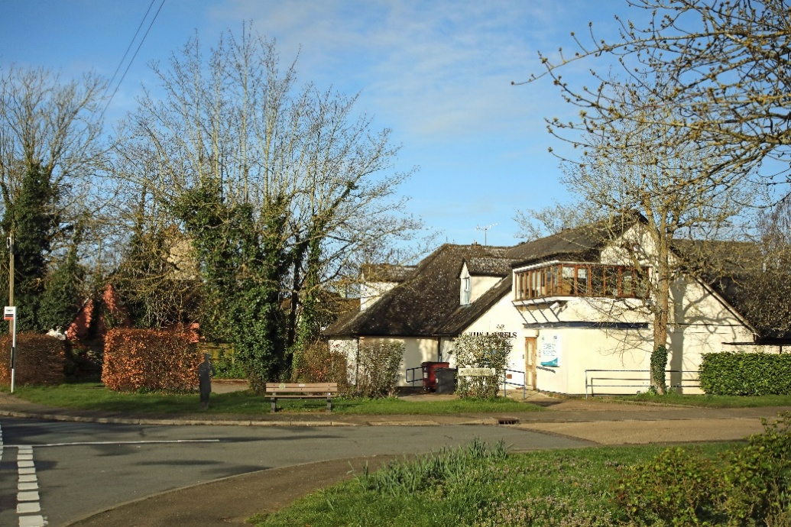
Figure 3.17 The Laurels surgery and pharmacy
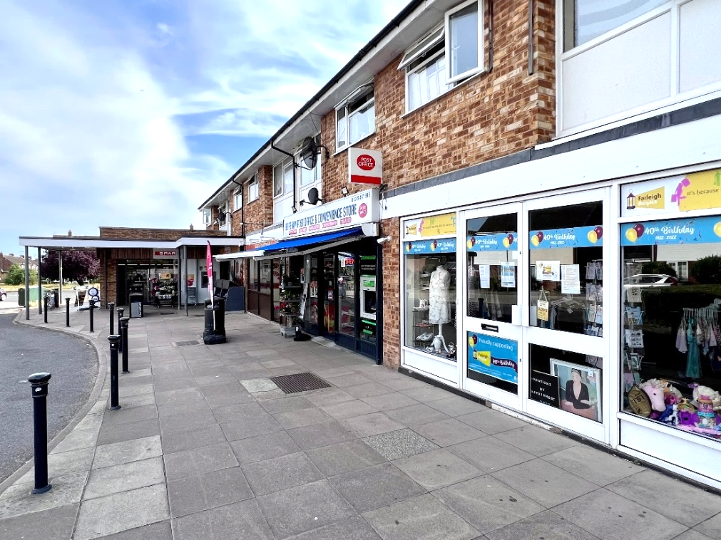
Figure 3.18 Parade of shops and post office on Butterfield Road

The village is well served with public houses and restaurants namely:- the Queen’s Head and the Six Bells public houses which both serve food and the Lion Inn public house including restaurant and hotel facilities and The Grange public house with restaurant. The Lion Inn is also a hotel. Other hotels are the Travel Inn (now Premier Inn Springfield) at Boreham Services and a second Premier Inn at Generals Roundabout Boreham interchange.
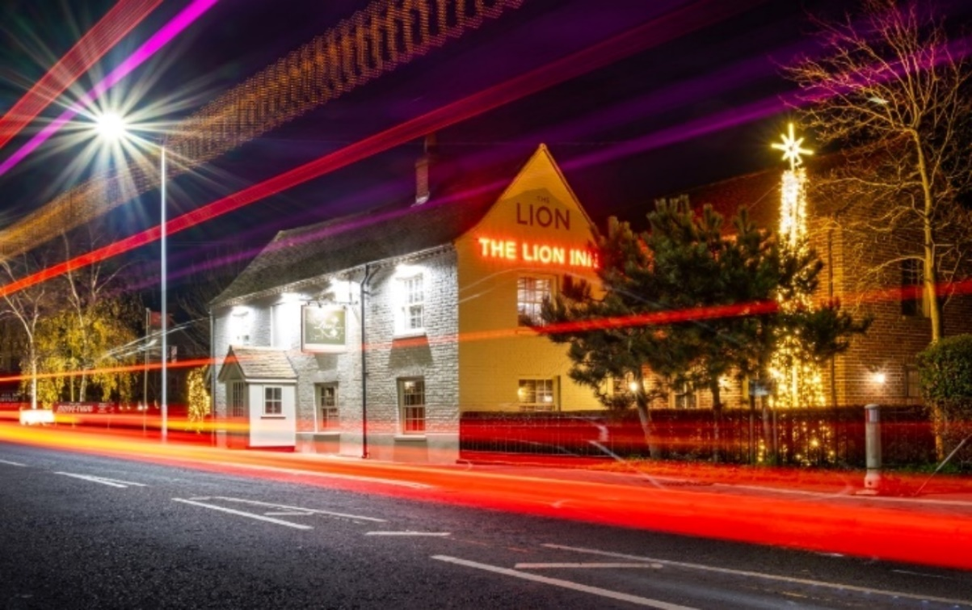
Figure 3.19 The Lion Inn, Main Road Boreham – Photograph courtesy of Mark Caldon
Boreham has a community primary school, with a register of approximately 210 children age range 4 to 11. It attracts pupils from outside the parish and is fully subscribed. The parish of Boreham also has New Hall School, a prestigious, independent school for boys and girls of all ages. Most senior school children from Boreham attend school in Chelmsford, travelling by bus or car.
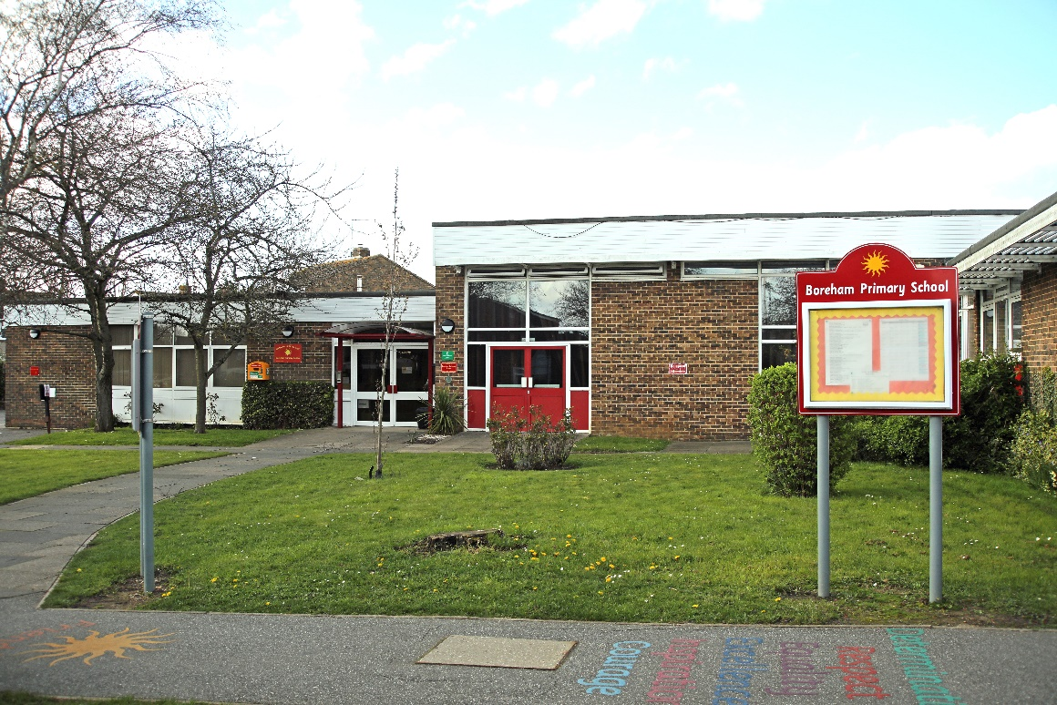
Figure 3.20 Boreham Primary School
Boreham is twinned with Ploubalay in Brittany, France and there are regular exchange visits between the two villages.
Additional information is set out in the evidence base document EB6 - Boreham Community and Leisure Evidence Base.

Transport (Moving Around)
Boreham lies alongside the main A12 Trunk Road (London to Gt Yarmouth) and also the Great Eastern Railway (London to Norwich and associated branch lines). These two main arteries effectively sever the Parish in two, with much of the land north of the A12 inconvenient to access without large detours to the few crossing points of these two obstacles. In addition, the Main Road B1137 is an additional obstacle to movement within the Defined Settlement Boundary. The village does suffer from regular rat running traffic trying to avoid the worst congestion on the A12; this is particularly apparent on Plantation Road and Church Road.
Boreham has been affected over the years from increasing car ownership and the associated parking issues. Much of the village lacks sufficient off road parking and cars parked without due regard to other street users can be a problem. An attempt to alleviate this problem has been tried in the new development off Plantation Road (Orchard Way). Here, in parts of this development the new policy of sharing street space between motorised vehicles, pedestrians and cyclists has resulted in no footways, the fronting housing being close to the street, combining to give the effect of a more constrained layout to encourage slower traffic speeds.
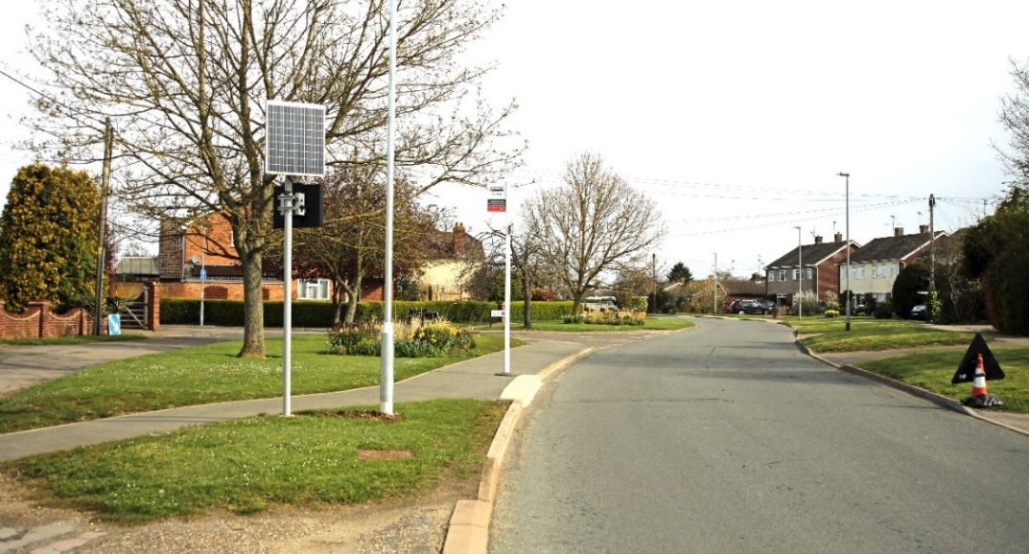
Figure 3.21 Plantation Road with bus stop
Boreham has two roads with protected lane status as described in EB5: Boreham Protected Lanes. One is Church Road and the other is Bird’s Farm Lane. Unfortunately, Church Road is very heavily used whenever there is an issue slowing or stopping traffic on the A12, particularly northbound. It is also subject to high levels of on road parking at the location of Black Bridge by recreational users of the river Chelmer.
Walking is a well-used method of moving around inside the Defined Settlement Boundary and there are several pedestrian only rights of way that make moving around simpler and more direct.
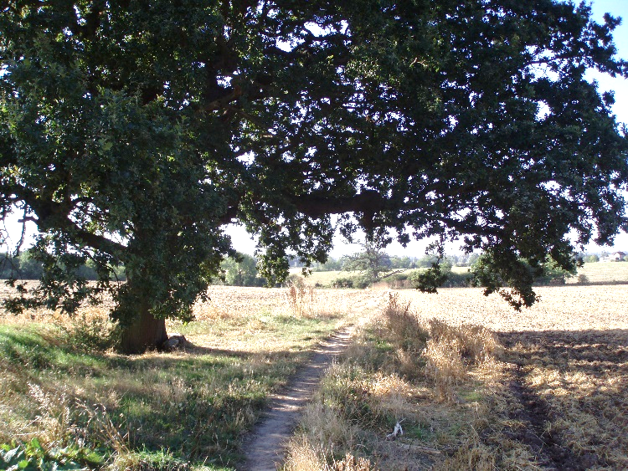
Figure 3.22 The footpath from Church Road to Risley Mead
Cycling is a mode of transport to be encouraged, however the historical provision of cycle routes has been poor, with most routes starting and ending on the road, which is a discouragement to cyclists. Boreham especially suffers from this issue as the cycle route along Main Road starts at the junction of Church Road and ends at Junction 19 of the A12 (“Boreham Interchange”).
Cycling along Main Road through the village is especially hazardous due to the traffic calming scheme introduced some years ago which narrows the carriageway by the use of local central islands. Once at the Boreham Interchange, the cycleway is effectively non-existent though it is signposted, it is far too hazardous to negotiate. These two major factors have effectively reduced the use of the cycleway to a minimum.
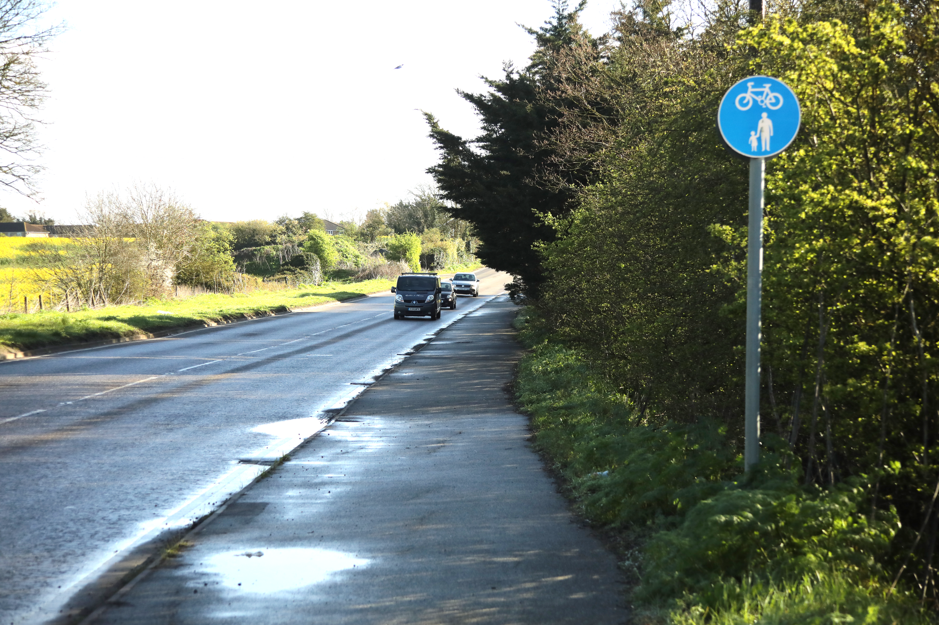
Figure 3.23 Shared use cycle path along Main Road
Boreham is relatively well served by public transport, namely buses but these are not used to their capacity and there is the always the risk of cancellation of services on efficiency grounds. A railway station (Beaulieu Park Station) has recently opened in the parish and provides local access to trains between London and Norwich. There is also a Community Transport system where users can telephone for a taxi type service. This service is reasonably well used by the older residents of the village. School transport for secondary pupils is good with pick points along the Main Road and also within the Defined Settlement Boundary along Church Road and Plantation Road.
These services remove vast numbers of private cars from the local highway network and are a very efficient means of transport. Boreham’s location within Essex is adjacent to two main road transport corridors i.e. the A12 and the A130/A131 and future development of these two elements could mean increasing traffic in the area. Along with the possible expansion of Stansted Airport and the new railway station at Beaulieu Park both putting more pressure on the local highway network within the parish.
This Neighbourhood Plan endeavours to outline strategies and policies to ensure that future developments do not compromise the free movement of people throughout the village and where possible provide improved facilities for all to use.
Additional information regarding transport in Boreham can be found in the evidence base document EB9 - Boreham Transport Evidence Base V2.
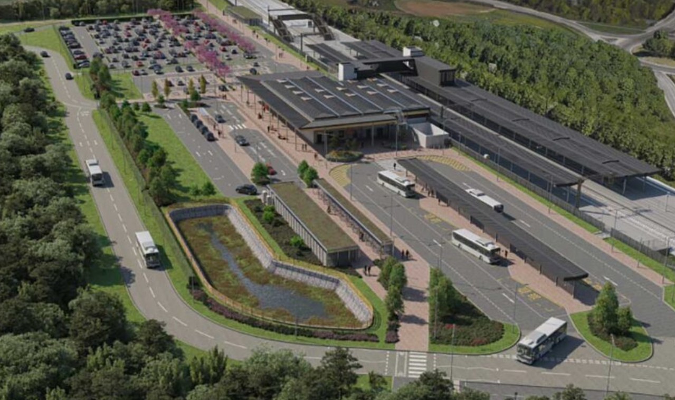
3.24 An artist’s impression of the new Beaulieu Park Railway Station courtesy of Network Rail

Housing
Present day Boreham is an interesting mix of very old, not so old and very new houses in different styles of housing development. Each reflects the fashion of the time it was built. Density is increasing from the bigger spaces around the older houses to the more closely packed recently constructed buildings. However, development throughout the village is either one or two storeys and has brick or rendered walls and tiled and pitched roofs.
There was significant residential development in Boreham during the 1960s and 1970s and, following the relocation of the A12 away from Main Road in 1971, the strip of land between it and Main Road has been filled with houses in cul-de-sacs ,or between existing dwellings or to replace houses on large plots of land. Each of the cul-de-sacs off Main Road has its own individual character and greens have been incorporated into most developments. There is a particularly fine large landscaped green between Boleyn Way and Main Road and an attractive central open grassed area with trees in Armonde Close.
Chelmsford’s Local Plan, adopted in 2020, identified that Boreham would provide 150 new homes to the East of Plantation Road as the total allocation for the village until 2035. These have now been completed. The housing development that has taken place has increased demand for infrastructure such as healthcare provision, education and parking. The Parish has a total population of 3,970 people (based on the 2021 Census) with 24% over 60. The proportion of detached homes in the Parish (45%) is higher than the national average of 22.5% with the majority of housing being owner occupied (73%) of households. There is a higher than average car ownership in Boreham (89.2% of households according to the 2021 Census).
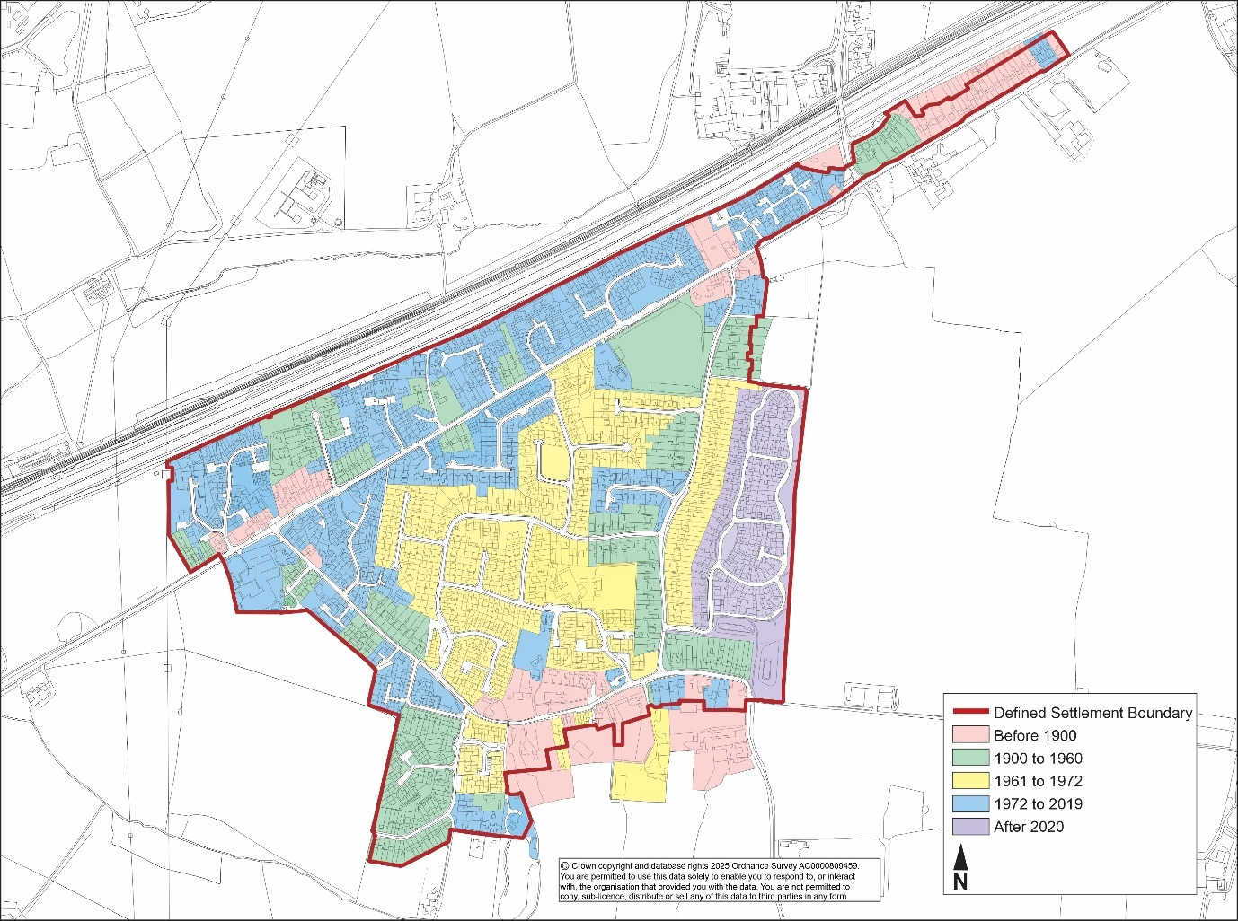
Figure 3.25 The development of Boreham Village and the current Defined Settlement Boundary
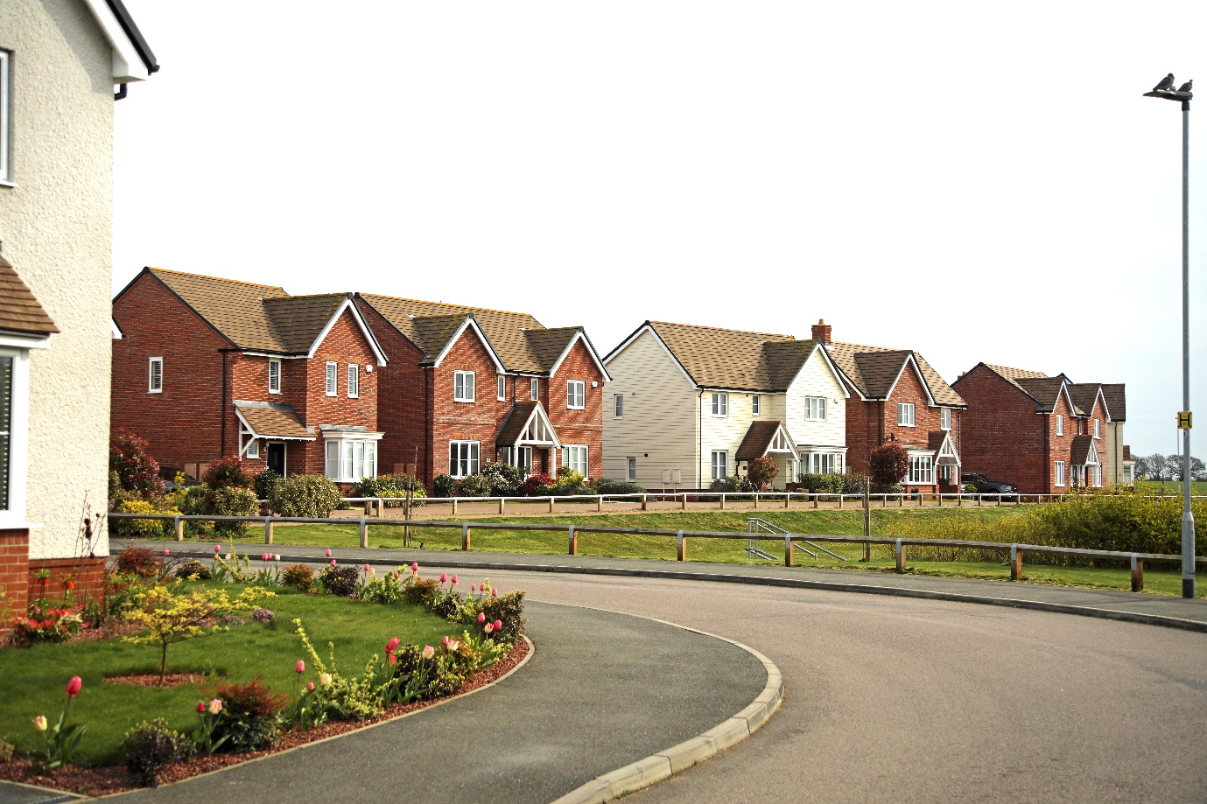
Figure 3.26 Houses in the Orchard Way development

3.9.1 The Village Centre
The centre of the village contains a typical 1960s development originally planned and marketed by the developers as a Garden Village. The frontages of all houses are required to remain open plan with limits on the heights of boundary fencing or walls. Houses vary between detached, link-detached, semi-detached and terraced houses and some bungalows. interspersed with green open spaces. At the same time, a small estate of 48 council owned properties was built at the eastern end of Juniper Road. These are mainly terraced houses with bungalows intended for occupation by senior citizens.
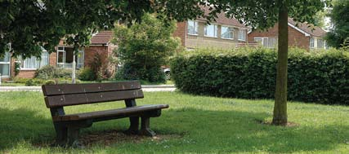
Figure 3.27 Green space on Butterfield Road
In 1975, The Willows estate of 47 houses was built to the south of the central area. The development retained a pond which has become a small wildlife area. The Garden Village was further extended in 1976 by an extra 53 dwellings of detached, semi-detached and terraced style houses.
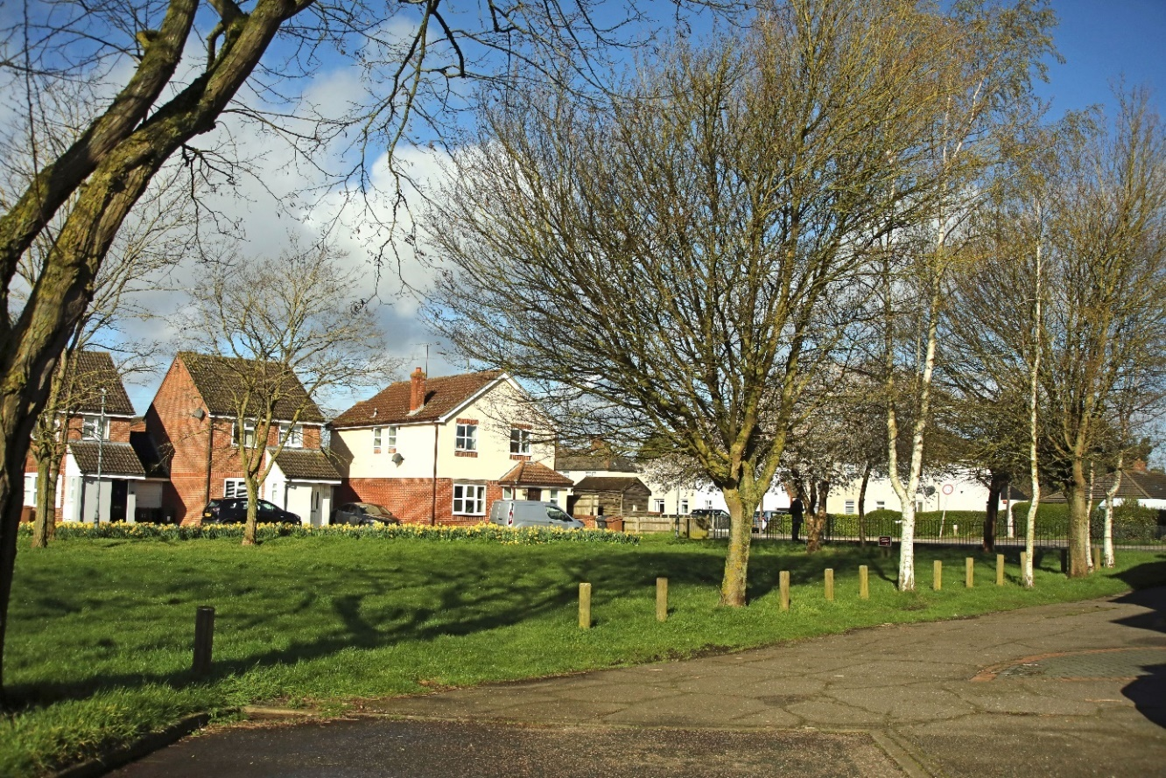
Figure 3.28 Holmans Close off Main Road
In 1994, the Holmans Estate of 56 houses was built on the site of the former Buxted chicken factory. A green open space incorporating a fenced off children’s play area is a feature of this development. A small development of six larger detached houses was built after the closure of the Boon’s coach company depot in 1999 this cul-de-sac is Boon’s Close. There has been some limited infilling over the years.

3.9.2 Main Road
Main Road is the main route through Boreham and, as such, does not reflect the character of the village. Most of the houses to the north of Main Road are set well back. There are also a number of listed buildings such as the Limes Cottage on the North side of Main Road and a conservation area on the South side at the junction with Plantation Road. The conservation area includes the timber framed Clockhouse, dating to the 16th century and the adjacent thatched Maltings Cottages and Maltings House, which were probably staff quarters for those working at the Clockhouse. Forming a triangular focal point with Maltings House at the junction of Main Road and Plantation Road are established businesses, the butchers and the Six Bells pub.
In 2016, Dukes Wood Close was built to provide 28 houses on land previously used for waste recycling. This has proved to be an attractive development with an open garden and play space and it has helped to tie in the eastern end of Main Road to the village.
The Cock Inn, towards the eastern end of the village is an old timber framed coaching inn dating back to the fifteenth century. It was also the dropping off point for the mail coach to deliver letters before Boreham had a Post Office. It was established as an inn in the 16th century. The General Court Baron and the Customary Court of the Lord of the Manor were also held here. The building is listed and is the original timber framed construction consisting of two gable ended wings which are linked by a central hall and was converted to 2 residences in 2017 with the addition of 3 extra units in the gardens and car park of the listed property.
The area north of Main Road between The Cock Inn (Waltham Road) and Damases Lane was included into the Boreham Defined Settlement Boundary when the Chelmsford Local Plan was adopted in 2020. This forms the eastern gateway to Boreham and has a clear identity of its own.
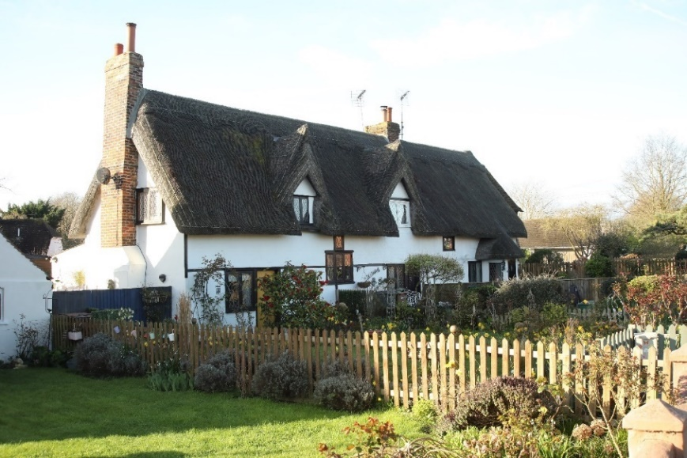
Figure 3.29 Maltings Cottages, Main Road

3.9.3 Church Road
Church Road runs from its junction with Main Road in the northwest, through the south eastern Conservation Area and down to the Chelmer Blackwater Canal at Black Bridge.
Church Road North-West is characterised by greens or verges and an interesting mix of old and new buildings ranging from the picturesque 17th century thatched cottages (Numbers 13 and 15 are Grade 2 Listed) to a two-storey block of four maisonettes built in 2004. Opposite the access to Butterfield Road and the main village shops and at the corner of Church Road and the Chase is Cooper’s Green planted with trees and shrubs. This was previously the site of an old people’s complex known as Coopers and was redeveloped in 2008 by the local Housing Association. The houses in the Chase were built by the Council at various times in 1950s and 1960s. In the 1990s, the Airey houses in Church Road were demolished and new houses and maisonettes built to a greater density, some without front gardens. Garage blocks are provided for The Chase and Old Forge Road.
Church Road East includes the Southern Conservation Area and much of Boreham’s early architectural history and St Andrew’s Church. Originally a small Saxon building and now grade 1 listed, the church is the heart of the village. The Old Vicarage is next to the church and has an 18th century frontage. It faces the timber framed 15th century Old Rectory across Church Road. Opposite the Church there are a pair of 18th century timber framed cottages, Ebenezer Cottage and Coppers, and further to the east is Babylon originally a 15th century timber framed house renovated in the 20th century and the impressive 18th century Boreham Manor. Part of Bowers is 17th century. The end house on the corner, Shottesbrook, in part dates from the 16th century. It has a Georgian frontage. Old Hall, once a 15/16th century Manor House, has a Victorian extension to the south.
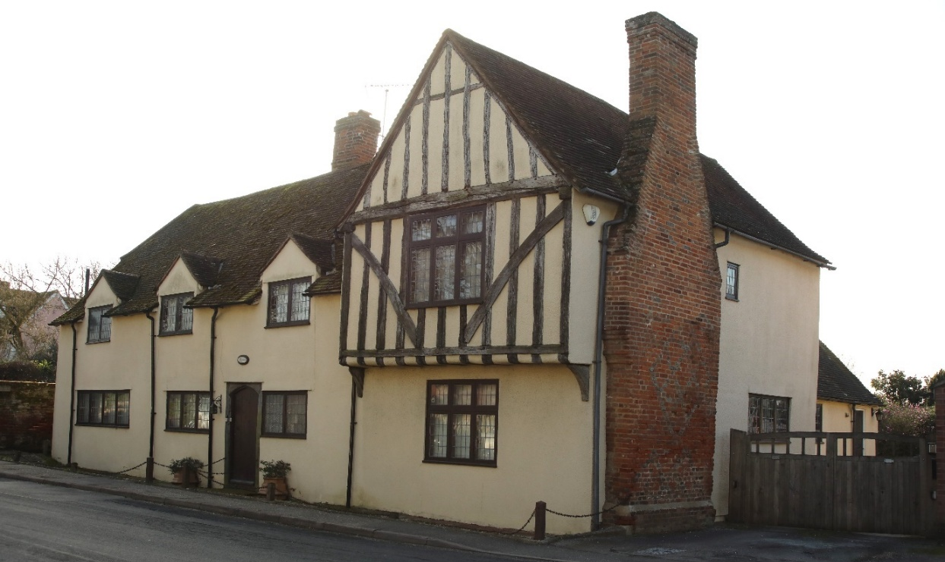
Figure 3.30 Babylon on Church Road
Viewed from any direction, the greens at the junction of Church Road and Plantation Road make a strong impact. The surrounding houses greatly benefit from this attractive setting.

3.9.4 Plantation Road
Plantation Road is the second major route through Boreham. It is an attractive road with houses set back to create a feeling of space and the recreation ground is at the northern end. The latest housing development of 150 units sits to the east of Plantation Road facing onto open countryside. The development of detached, semi-detached and terraced houses of mixed unit sizes was completed in 2021 and is now fully occupied. Access to this development is via Plantation Road.
3.9.5 Beyond the Defined Settlement Boundary
There are a significant number of properties outside the Defined Settlement Boundary. Many of these are along Waltham Road through to Runsell Green and on Birds Farm Lane, Generals Lane to the West and Damases Lane to the East. They tend to be detached houses on, isolated plots without immediate neighbours and without public utilities of gas and mains drainage. The majority of these buildings are late Victorian or early 20th century. Generally, development outside the Defined Settlement Boundary has been deterred by the local planning authority and very few have been built in the last 50 years although some of the existing houses have had significant upgrades to bring them to modern day standards. A number of these buildings outside the Village are listed, including Great Holts and Little Holts, Brent Hall, Wallace’s Farm and Bird Farm in Waltham Road and Bulls Lodge Farm, Mount Maskells and New Hall in Generals Lane.
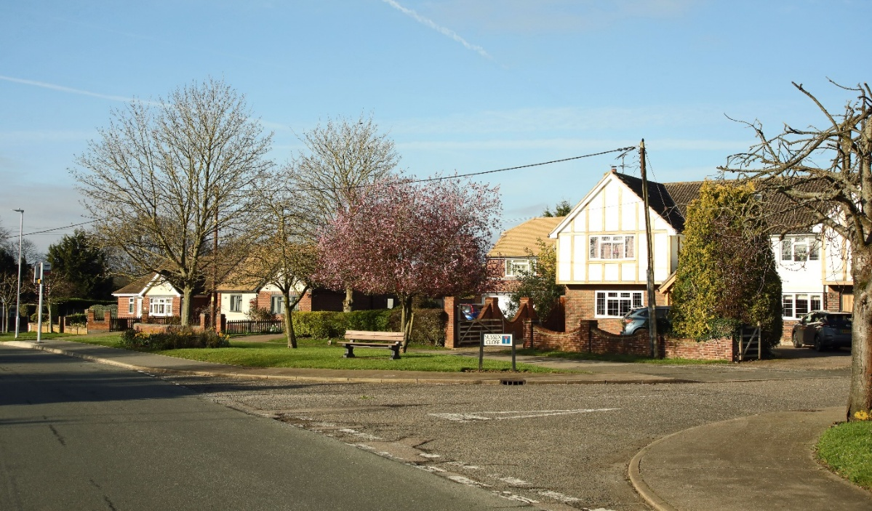
Figure 3.31 Plantation Road at Sussex Close
Additional information can be found in the evidence base document EB7 - Boreham Built Environment Evidence Base. Boreham Defined Settlement Boundary is shown in Figure 3.25.

Business/Local Economy
Boreham has always benefitted from being on the Roman Road which joins Colchester and London and commuting workers taking advantage of the proximity to Chelmsford and to London add to the local economy. This Main Road has also benefitted from the patronage of those travelling through Boreham at its public houses and inns. This is particularly evident with the cluster of services at Boreham interchange (Junction 19 of the A12). The Generals roundabout is served by a Premier Inn and pub restaurant with electric car charging facilities. Towards Chelmsford there are additional services including a Travelodge, McDonalds restaurant and BP service station. The community is also well served with local shops and a post office which offer employment and support the local economy.
The parish has a long history of agriculture and horticulture, largely due to the richness and fertility of the brick earth soil combined with boulder clay. Until well into the 20th century, farming was the chief occupation of the majority of Boreham’s inhabitants, most of whom worked locally. Although it is not the agricultural community it once was, much of the parish land is still used for agriculture and the strong agricultural heritage is preserved in a legacy of buildings and the rural environment. It benefits from high light levels and is mainly grade 2 classified agricultural land that supports several farms growing a wide range of crops.
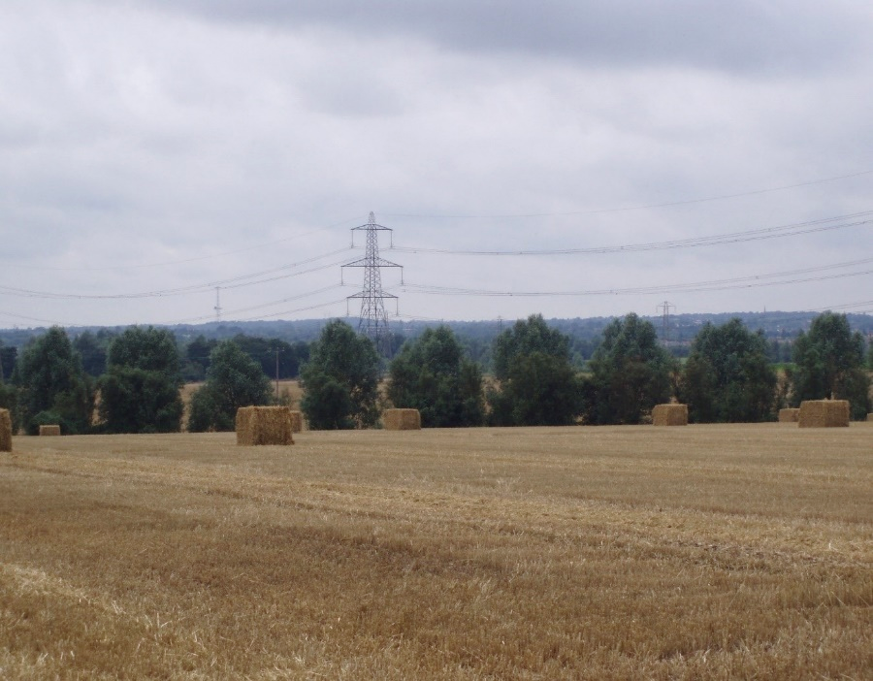
Figure 3.32 shows the agricultural landscape which separates Boreham from Chelmsford: a view from the western edge of Boreham village looking into the valley of the Bulls Lodge (aka Boreham) Brook lined by cricket bat willows, beyond which the trees along the Chelmer blend with the distant wooded hills to create a bosky background. The pylon lines are typical of the landscape in the west and north of the parish, the mast which can be seen on the distant ridge is a listed structure, one of the original chain radar towers of 1940 moved to its present location from its original position in Canewdon.

In addition to farming, many areas have, and will for the foreseeable future, be excavated to gain access to the rich seam of gravel that runs under the parish. Boreham Airfield, built for the US Air Force in 1943 and subsequently used for car and motor cycle racing was in the north of the Parish. This former airfield and the surrounding land over two square miles, are said to be the largest gravel pit in Europe and excavation is expected to continue for another 10 or more years. At the end of this period, the current approval requires the land to be reinstated as parkland for recreational purposes. However, in 2022 the parish boundary was redrawn and an area of the north west portion of the parish, including part of Boreham Airfield has been removed and allocated to a new parish (Chelmsford Garden Community). Gravel extraction continues within Boreham Parish boundaries.
Waltham Road Industrial Estate marks the entrance into the village from the north and supports some additional jobs. Enterprises at this site bring a significant increase of heavy vehicles to the village, increasing noise and traffic seven days a week. There is also light pollution from floodlighting of the site. Further north along Waltham Road at Wallace’s Lane, and at Boreham Interchange there are several additional, varied business premises. The Essex Police Motor Division and Essex Police Helicopter service occupy sites on the disused airfield which is located on Holts lane off Waltham Road.
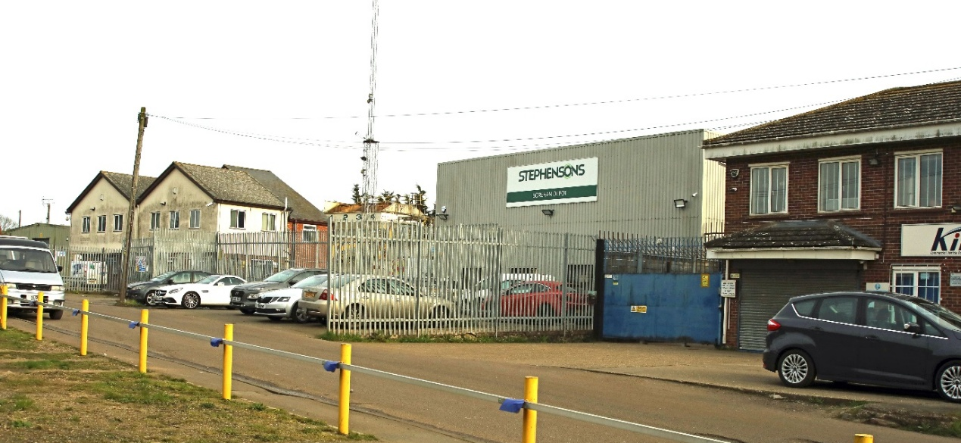
Figure 3.33 Industrial Estate on Waltham Road
Small local businesses and sole traders including those associated with the building and related trades and personal and professional services make a significant contribution to the local economy. The number and scope of home based business has increased since the Covid 19 pandemic as has the number of people working from home. There is also public sector employment relating to local schools, healthcare and other amenities.
Local businesses require the support of adequate broadband and mobile services and demand for these services is increasing. Currently, broadband speeds are slow and mobile coverage varies across the parish.
Additional information can be found in the evidence base document EB8 - Boreham Business and Local Economy.

SWOT Analysis
Table 3.2 The identified strengths, weaknesses, opportunities and threats facing Boreham.

Strengths | Weaknesses
Close to good road transport links  Local Primary School  Local shops and post office  Separate village identity  Many local organisations  Surrounded by countryside  Restricted development sites in CCC Local Plan  Local doctors’ surgery and pharmacy  Local pubs and restaurants  2 Recreation Grounds  Chelmer River valley recreation and natural environment  Compact Defined Settlement Boundary  Bus services  Sports Clubs  Modern village hall and church hall  Ancient church (more than 1000 years old)  Conservation areas  Grade 1 listed buildings, St Andrew’s Church, New Hall and Boreham House | A12 Road Noise  Large portion of parish inaccessible due to A12 and railway line  Traffic rat running Church Rd/Plantation Rd  Main Road designated A12 diversion route  Main Road traffic volume and speed  Church Road/Plantation Road traffic speed  Residential parking  School pickup parking  Little local employment  Pressure for primary school places  Obstructive parking in Church Road  Excessive parking near River Chelmer  Lack of dedicated cycle facilities  Poor broadband & mobile signal in some areas  Lack of pre-school/nursery places
Opportunities | Threats
Chelmsford NE Bypass  Beaulieu Station  Mineral extraction land restoration (possible creation of water park)  Improvement of local shopping area and associated parking  Improvement of local environment associated with the proposed A12 widening and improvement (A12 scheme currently cancelled but may be re-instated)Improve cycle and pedestrian facilities especially into Chelmsford City using CIL funding  Countryside walks/footpaths using other grant funding and CIL  Improve youth and community amenities  Improve mobile and broadband connectivity  Create wildlife/habitat corridors to adjoining areas  Re-ordering of church to create a flexible, usable – community asset. (survey to be commissioned shortly)  Improve connectivity between north and south of the A12 and railway line | Solar energy development (with no chance of CIL)  Potential target for housing developers due to accessible location  Chelmsford NE Bypass becoming possible outer M25  Beaulieu Station (parking overspilling into village)  Potential spread of NE Chelmsford development  No clear boundary between Chelmsford city and village (constantly under threat)  Reducing bus services  Under-provisioned doctor’s surgery  Under provisioned primary school  Combined church services (shared with Beaulieu)  Church closure (underused)  Structural failings in church  More developments with no infrastructure improvements  Heavy and inappropriate use of the river and -footpaths having a detrimental effect on natural -habitats  Exhausted gravel working sites having limited -community access once restored

VISION & OBJECTIVES
In 2019 the Steering Group carried out a Parish wide Survey of the community. From the responses received and contributions at an Open Day held in the Village Hall, the Vision Statement and Objectives have been developed. There was an informal consultation over the summer of 2022 and the draft plan was updated based on the views and comments received from respondents as to how they perceive the way forward.

Vision Statement
For Boreham to retain its identity as a village, distinct and separated from Chelmsford by protected open space in an agricultural landscape/rural setting, and to develop in ways which protect our environment and are supported by our local residents, businesses and organisations.

Summary of Objectives

4.2.1 HISTORIC ENVIRONMENT
Objective 1: To maintain Boreham’s separation from Chelmsford, ensuring the parish keeps its historic character, as a village settlement set in an agricultural landscape.
Objective 2: To retain and where possible enhance designated and non-designated heritage assets and their settings.
Objective 3: To maintain the historic character of Boreham and celebrate the history of the village, making local history accessible to the community.
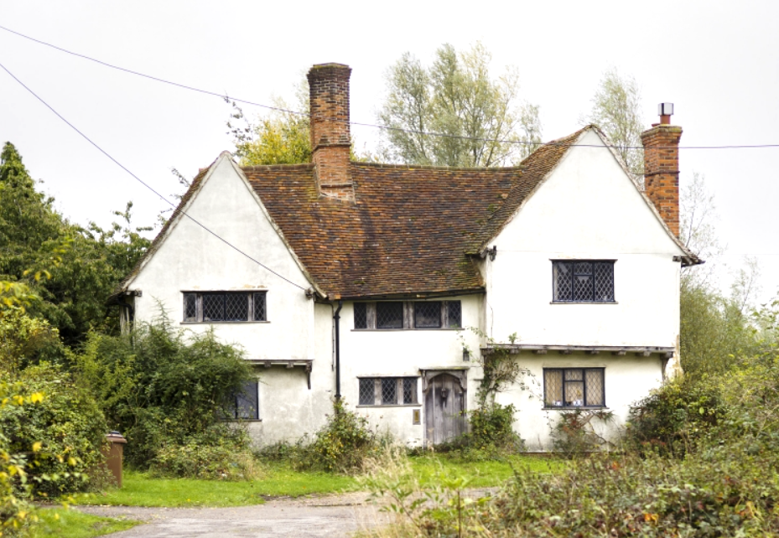
Figure 4.1 Bird’s Farm House

4.2.2 NATURAL ENVIRONMENT
Objective 4: To conserve and enhance Boreham’s declining natural environment, to deliver a net gain in biodiversity and improve soil conservation throughout the parish.
Objective 5: To improve wildlife corridors and connectivity throughout Boreham.
Objective 6: To conserve hedgerows which provide habitats and serve as wind breaks and reduce soil erosion by the wind and water run-off.
Objective 7: To reduce the conflict between recreational use of environmental assets and biodiversity objectives.
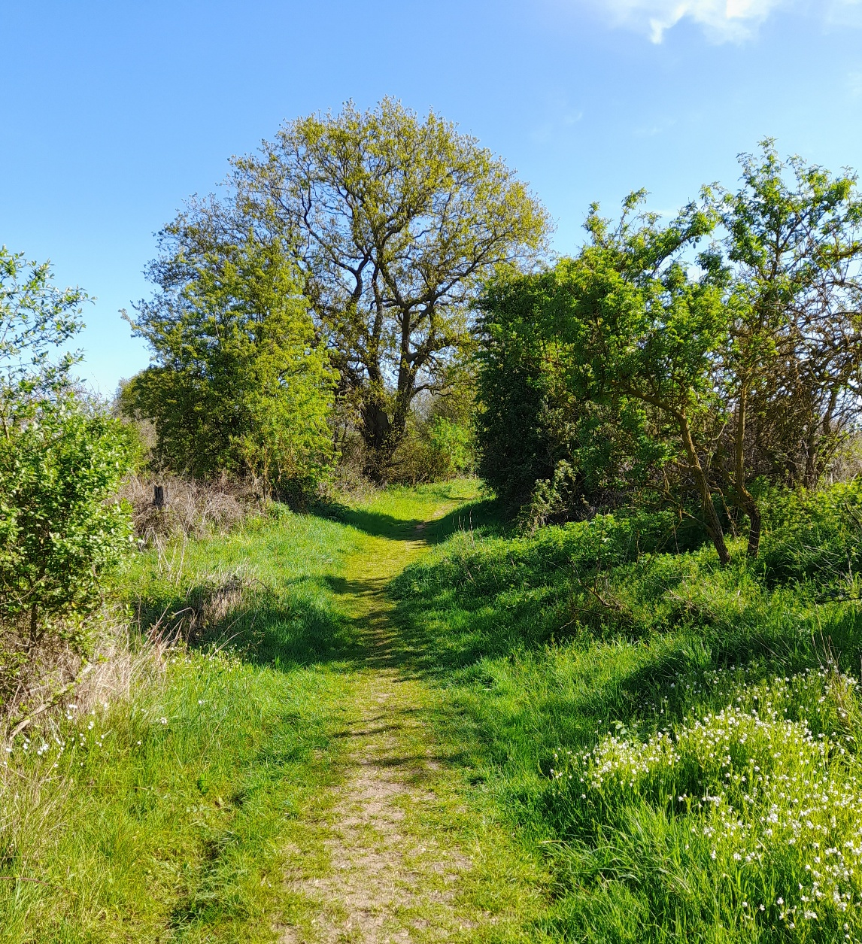
Figure 4.2 The green lane leading from the Waltham Road to Toppinghoe Hall wood

4.2.3 LANDSCAPE CHARACTER
Objective 8: To maintain a clear separation of Boreham village from the urban edge of Chelmsford.
Objective 9: To maintain the open agricultural landscape of fields and hedges surrounding the village.
Objective 10: To protect views and open spaces which are a vital and integral part of Boreham’s character valued by the community.
Objective 11: To facilitate the conservation and enhancement of the Chelmer Valley’s landscape character.

4.2.4 BUILT ENVIRONMENT
Objective 12: To enhance the built environment to blend in with the natural and historic local character.
Objective 13: To promote high quality design and sustainability in the built environment with specific reference to energy efficiency, water management and use of native landscape planting.

4.2.5 COMMUNITY AND LEISURE
Objective 14: To support a flourishing and inclusive community through the provision of a mix of housing types, sizes and tenures to meet local need including accommodation that is or can be made adaptable for a variety of life stages, including independent living housing for older people and people with disabilities, elderly accommodation and care, with associated facilities and infrastructure for: community life, health, education and leisure for all ages and abilities.
Objective 15: To provide local, sustainable and high-quality early years education and childcare, and school places for all the children of the parish and to support and promote the provision of healthcare for increased patient numbers within the parish.
Objective 16: To maintain and, where possible, increase the availability of public footpaths, cycle routes and bridleways.

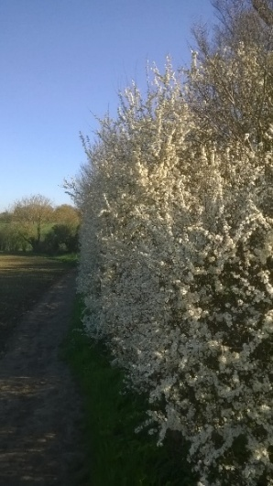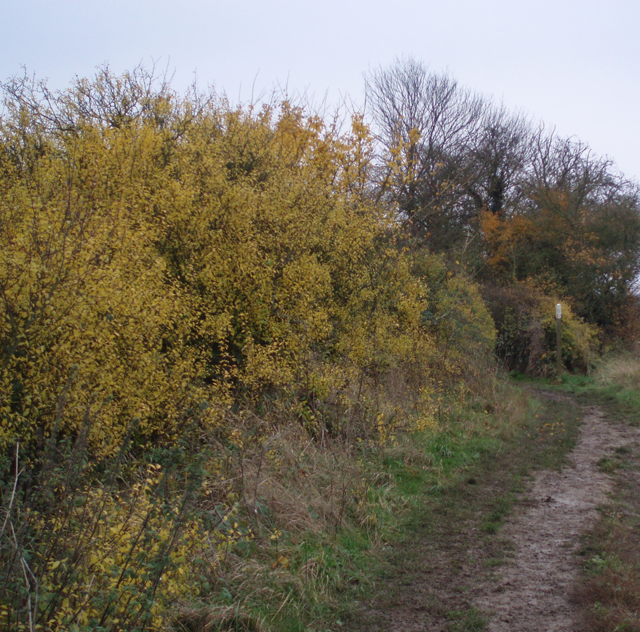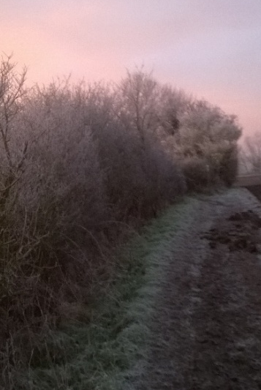
Figure 4.3 Footpath running south from the village into the Chelmer valley, in spring with the blackthorn in full bloom, in autumn and again on a frosty winter morning. The blackthorn and elm hedge includes other woody species and coppice stools, indicative of a hedge once managed in the traditional Essex style. The northern end of this hedge adjacent to the Bulls Lodge Brook contains a substantial earthwork probably the remains of a medieval mill dam.

4.2.6 BUSINESS AND ECONOMY
Objective 17: To encourage the retention, creation and growth of local employment opportunities without; increased local use of HGVs compromising the nature of the parish as a rural community, or negatively impacting the character and appearance of the village.
Objective 18: Improve service to gigabit speed broadband and 5G mobile connectivity within the parish.

4.2.7 ACCESS AND MOVEMENT
Objective 19: To make it safe and convenient for all people to move around the village and reduce the need for private cars for local journeys.
Objective 20: To improve the connectivity by active and sustainable modes between the main village and the area of the parish north-west of the A12 trunk road and the railway line.
Objective 21: To promote the use of active and sustainable modes of travel including walking, cycling and public transport.
Objective 22: To improve connectivity across Main Road by slowing traffic and deterring through traffic in order to increase pedestrian safety.
Objective 23: To deter through traffic from using Church Road/Plantation/Road/Waltham Road.
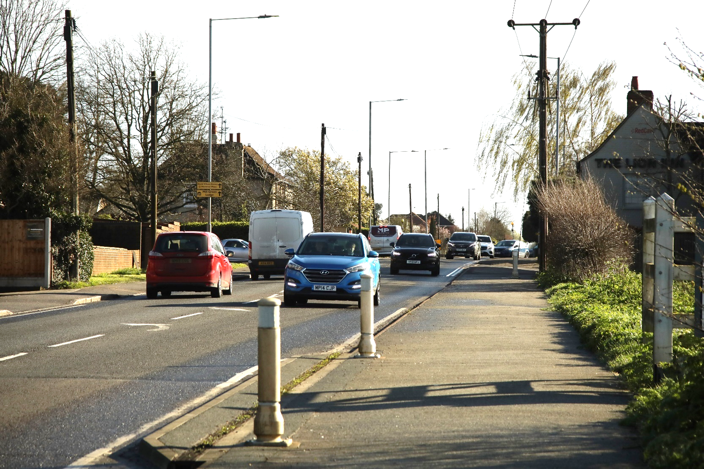
Figure 4.4 Morning traffic on Main Road

POLICIES
This section contains the policies that will deliver the objectives summarised in section 4.2, together with the justification and evidence upon which the policies are based.

5.1 Historic Environment Policy
Key issues:
Boreham has a long history, and its historic environment is of great significance, it is both sensitive to change and a critical factor in defining the character of the parish. Archaeological sites and deposits have been recorded in advance of development at many locations throughout the parish. Accordingly, the historic environment of Boreham requires careful conservation and enhancement to accommodate change as the parish moves forward.
Objectives:
Objective: To conserve designated heritage assets and their setting, non-designated assets (including archaeological sites) and landscape features to maintain and enhance their significance to the character of Boreham.

Policy 1 Heritage
- Development proposals shall preserve and, where appropriate, enhance designated and non-designated heritage assets including their setting which make a significant contribution to the historic fabric of Boreham. Development proposals affecting designated and non-designated heritage assets (or their settings) shall be evidenced by appropriate analysis to enable a balanced judgment regarding the scale of any harm or loss to the significance of the heritage asset and its setting. Development proposals affecting designated heritage assets shall be considered against any public benefits arising from the proposed development. Development proposals shall seek to conserve and enhance the historic grain of the landscape wherever possible.

Justification:
There are two Conservation Areas entirely within Boreham: Church Road, Boreham, and Main Road/Plantation Road, and a large area in the southern part of the parish lies within the Chelmer and Blackwater Navigation Conservation area. There are over 30 Listed Buildings, and a Registered Park and Garden at Boreham House. Boreham’s Listed Buildings are set out in Appendix 1. Boreham Parish also includes the following protected lanes amongst its non-designated heritage assets: Bird’s Farm Lane, Church Road, Noakes Lane and Boreham Road. There is an action in the Action Plan at Table 6.1 to create a local list of non-designated heritage assets which would be used to assist planning and decision making.
Heritage assets both designated and non-designated are held in high regard by the Parish and are an essential part of its history, character and appearance. The NPPF (December 2024 as updated in February 2025) states “Heritage assets range from sites and buildings of local historic value to those of the highest significance, such as World Heritage Sites which are internationally recognised to be of Outstanding Universal Value. These assets are an irreplaceable resource, and should be conserved in a manner appropriate to their significance, so that they can be enjoyed for their contribution to the quality of life of existing and future generations.” and requires that there should be a positive strategy for the conservation and enjoyment of the historic environment. English Heritage and Commission for Architecture and the Built Environment’s (CABE) ‘Building in Context Toolkit’ provides information on heritage and design issues to stimulate a high standard of design when development takes place in historically sensitive areas. Where necessary creative uses to sustain heritage assets will be supported where it can be demonstrated that these solutions will stop any loss of significance, and secure the positive contribution that conservation of heritage assets can make to the parish.
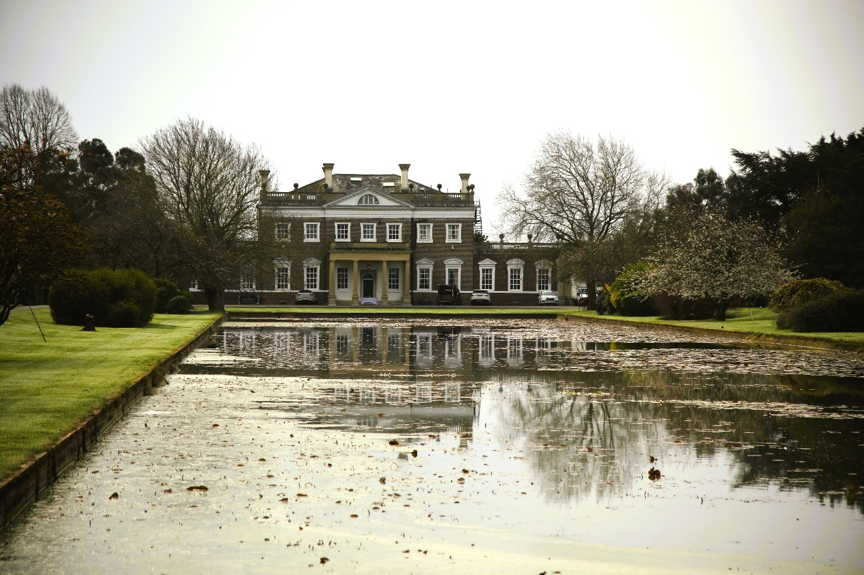
Figure 5.1 Boreham House
There are a many non-designated heritage assets with archaeological interest throughout the parish some are identified on the Essex Historic Environment Record and considered in the Boreham Parish Historic Environment Characterisation (BPHEC) part of the evidence base for this plan. The BPHEC provides an integrated overview of the historic environment of Boreham Parish. This study has emphasised the close connection between the natural and historic environments and the national conservation agencies have noted the importance of an integrated approach to the natural and historic environments in neighbourhood planning. The grain of the historic landscape, the pattern of hedges, woods tracks and paths are non-designated heritage assets of great historic (as well as natural significance) and a key element in the rural identity of the Parish.
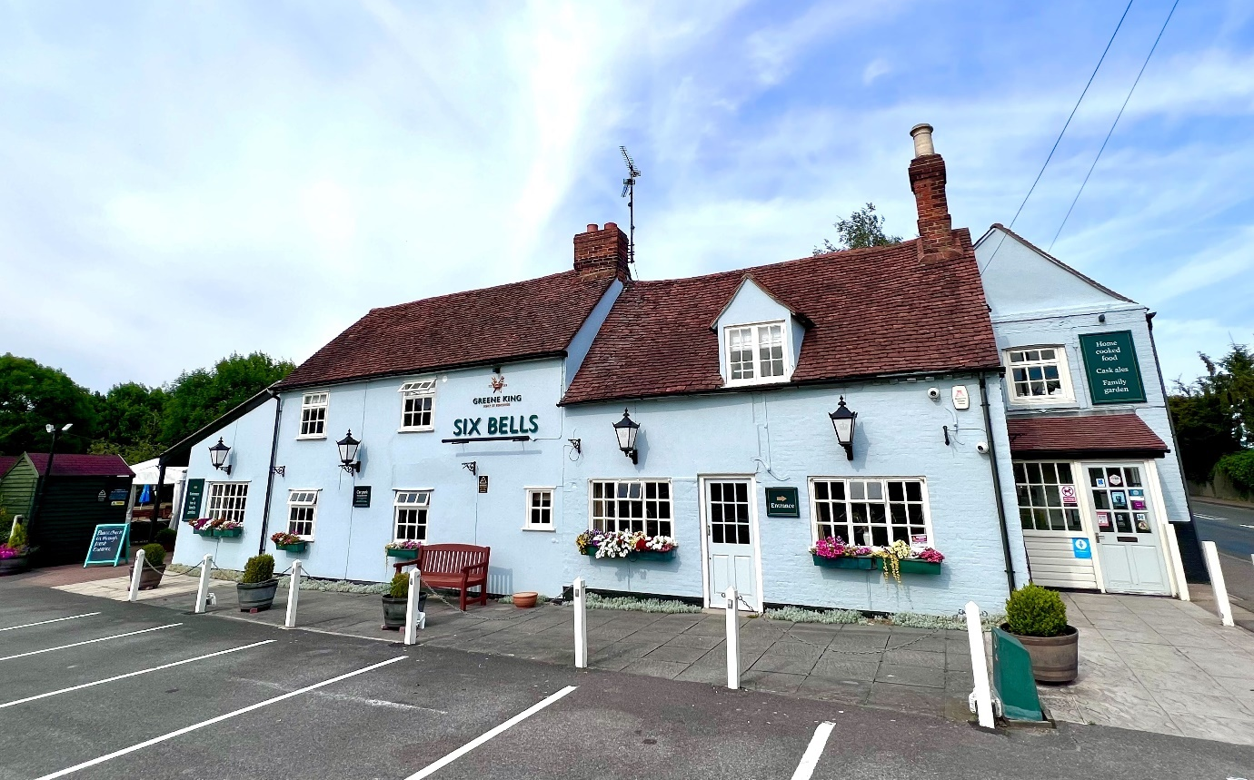
Figure 5.2 The Six Bells public house

5.2 Natural Environment Policies

5.2.1 Biodiversity
Key Issues:
The UK has lost more of its biodiversity than any other G7 country and is in the bottom 10% of countries globally but this decline, largely due to habitat destruction from development and intensive farming, can be reversed. There are 6 recognised Local Wildlife Sites (LoWS) either wholly or partially in Boreham Parish (Register of Chelmsford Local Wildlife Sites (updated 2016) see the BNDP Natural Environment Evidence base for more information) and these are all privately owned: The Grove, Boreham Rd Gravel Pits, Boreham Meads, Bulls Lodge Lagoons and Toppinghoehall Wood, ancient woodland (partly in Boreham and partly in Hatfield Peverel parish). The LoWS include ancient woodland, streamside woodland, lakes and wetlands and provide varied habitats which support significant biodiversity. These are described in Section 3.4 with additional detail in the evidence base (EB2 Natural Environment)
In addition to the LoWS there are other sites and key wildlife corridors across Boreham. These include hedgerows (both ancient and more modern), wildlife gardens, burial grounds, areas of woodland and uncultivated grassland such as field margins and verges. The hedgerow corridors, field margins and verges provide needed connectivity between and create habitats for all types of wildlife. These can be enhanced and improved by the addition of more hedges featuring native hedgerow plants and groups of native trees which provide food and shelter in new and existing developments.
In Boreham, a decline in biodiversity has been observed at these and other wildlife sites. This has been confirmed by local ecologists who have conducted regular surveys of species of insect, wildflowers, birds and mammals. They have also observed changes in the habits and make up of local wildlife in response to global warming. In the 2020 Questionnaire returns, 99% of respondents agreed that our local, natural environment plays a key role in defining Boreham’s character and enhancing the quality of life in the village. Therefore, we are taking active steps to reverse the decline and to restore biodiversity where possible. This includes the Parish Council’s Chantry Field nature reserve community project which has benefitted from support from the Essex Forest Initiative. We also note the provisions of the Essex Local Nature Recovery Strategy to address declines in biodiversity across our county.
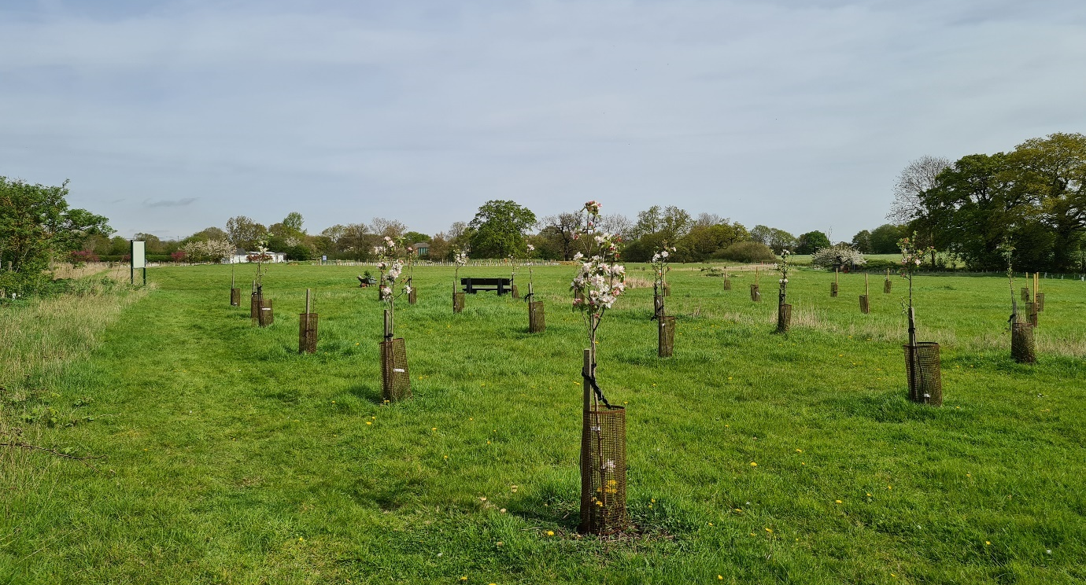
Figure 5.3 The recently planted Seabrook Heritage Orchard on Chantry Field
Objectives:
The community has indicated a strong desire that any development should preserve the rural feel of Boreham, preserve open and green spaces and protect the local wildlife and habitats throughout the parish. We also wish to contribute to the goals to reverse biodiversity loss enshrined in the Environment Act 2021 and support ‘at risk’ species in our parish. It is our view that this requires action at a local which goes beyond the explicit requirements codified in the Chelmsford Local Plan (Strategic Policy S4 and Policy DM 16 (Ecology and Biodiversity).

Policy 2 Biodiversity
- As appropriate, all development will be required to demonstrate how they will conserve or enhance existing ecological assets. This should include retaining existing mature trees, hedgerows and habitats which are important for their historic, visual or biodiversity value.
- Development proposals for new dwellings shall, as appropriate, seek to:
- Deliver and increase the connectivity of wildlife corridors using hedgerows, stands of native tree species and green spaces; and
- Deliver a minimum 10% biodiversity net gain (BNG) on qualifying sites at the development site (preferred) or elsewhere within Boreham Parish prior to delivering off site having regard to the Essex Local Nature Recovery Strategy rather than through BNG offset schemes; and
- Enhance the current biodiversity of Boreham by the introduction of bat roosts, hedgehog friendly gardens and swift boxes to new homes; and
- Restrict planting on a development to locally native species – per the list in Appendix 3; and
- Take account of the potential impacts of climate change in the design of developments (e.g. include drought resistant plants (Appendix 3), rain water capture measures etc.) and providing rainwater harvesting on site to minimise overall water consumption and maximise its reuse; and
- Consider and avoid any potential future conflict between recreational use of environmental assets and biodiversity objectives.
- On qualifying sites, exceptions to the above will be limited to circumstances where the need for, and the benefits of the development in that location, clearly outweigh any loss and where any such loss will be mitigated where appropriate.
Justification:
In the Boreham Neighbourhood Plan Questionnaire (the Questionnaire), over 88% of respondents strongly agreed that the natural environment plays a key role in defining Boreham’s character and enhancing the quality of life. The UK Government Natural Environment White Paper 2011; Making Space for Nature, argues that wildlife sites need to be in good condition, larger and connected up. The Environment Act of 2021 further emphasizes the need to make space for nature. In Boreham parish, we have observed a decline in our natural environment (as documented in EB2: Natural Environment in the evidence base) and recognise the need to ensure this does not continue. The local community are supporting efforts to protect and enhance our green spaces to improve biodiversity throughout the Parish.
One tool for delivering biodiversity improvements is to monitor biodiversity net gain (BNG). This is a standardised approach to development, and land management, that aims to leave the natural environment in a measurably better state than it was beforehand. The word ‘biodiversity’ comes from ‘biological diversity’ and refers to the variety of all living organisms, including animals, insects, plants, bacteria and fungi in a habitat.
BNG provides a proxy for biodiversity in a given type of environment. BNG is the delivery of measurable improvements in biodiversity from this proxy value by creating or enhancing habitats in association with development. Biodiversity net gain can be achieved through a combination of on-site and off-site measures. The requirement for a minimum of 10% BNG became mandatory for large sites in February 2024 and for small sites from April 2024. BNG is already required through national planning policy in England and Wales. For any qualifying development, this can be achieved on site, off site, or through a combination of on-site and off-site measures. Exempt development is set out in Government guidance.
This policy supports Objectives 5 and 7.

5.2.2 Landscape setting, character, and the protection of high quality agricultural land
Key Issues:
Boreham is a rural village surrounded by farmland. This land is an attractive greenfield site for developers and could be sold for development at premium prices. In the Questionnaire responses, local residents confirmed the importance of retaining the rural nature of the village. Farming provides some local employment and the rural landscape also provides cover for ground nesting birds, hares and other wildlife. Recently, EDF Renewables has been granted development consent for a 940 acre solar farm, a significant portion of which will occupy good quality farmland in Boreham Parish.
The area of the UK set aside for crops is declining due to climate change as fields are set aside to grow trees for carbon offset, locate solar farms and for other uses and due to seasonal flooding. Yields are also declining as a result of climate change and heavy rains followed by periods of drought. As an example, in 2019, wheat production fell by 40% to its lowest recorded level since the 1970s due to wet weather during winter planting. (Department for the Environment Food and Rural Affairs Farming Statistics – final crop areas, yields, livestock populations and agricultural workforce at 1 June 2020 United Kingdom). In the same report it was reported that 41,000 agricultural jobs were lost. Clearly, we need to preserve our good agricultural land for food production where we can.
Objectives:
The objective of this policy is to maintain the historic character of Boreham as an agricultural community surrounded by productive farmland in accordance with the express wishes of residents of the parish. It covers the Objectives 6 and 8 to 11 as set out in Section 4.2.3. This includes protecting the long views to and from the village in all directions including across the Chelmer Valley in the south and to the north. The map at Figure 5.6 shows (by arrows) the long views from Boreham to be protected which are all key to the landscape setting of the village. This map was also included in the Boreham Village Design Statement.

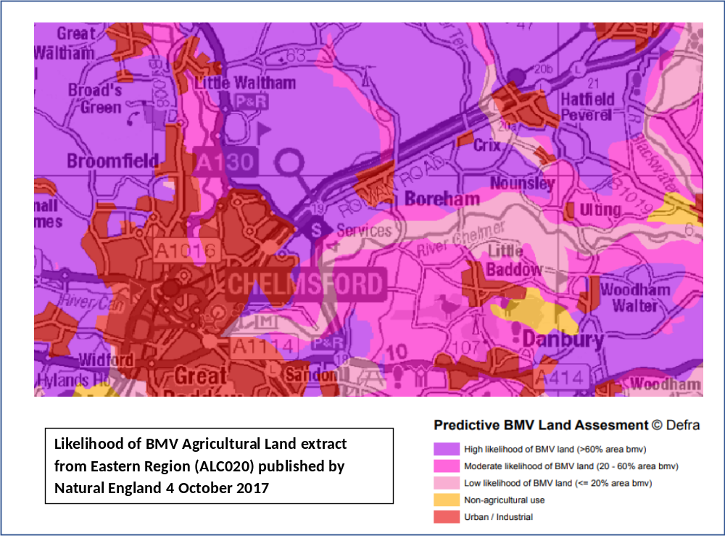
Figure 5.4 DEFRA Predictive Best and Most Versatile (BMV) Land Assessment dated 4 October 2017

Policy 3 Landscape Setting, Character, and the Protection of High Quality Agricultural Land

- Development proposals will be supported which:
- Protect against the loss of Best and Most Versatile (BMV) agricultural land within the Parish; and
- Have regard to and respect for the character of the landscape and its sensitivity to change.

- Any proposed development must demonstrate that the proposals will not detrimentally impact the views, landscape setting and character of the area. Refer to Figure 5.6 for the views to be protected. For major development proposals (that is those of 10 or more dwellings, and/or development proposals on a site area of 1 hectare or more), or developments of any size outside the Defined Settlement Boundary, this should be demonstrated through an appropriate visual assessment.

Justification:
99% of residents responding to the Questionnaire expressed the view that it is very important that the village should retain a green area around the village to keep it a separate entity distinct from urban Chelmsford and that, in particular, the village should continue to be separated from Springfield and Beaulieu Park by the farmland between the village and the A12. Land to the east of the village provides a green area separating Boreham from its neighbouring village, Hatfield Peverel.
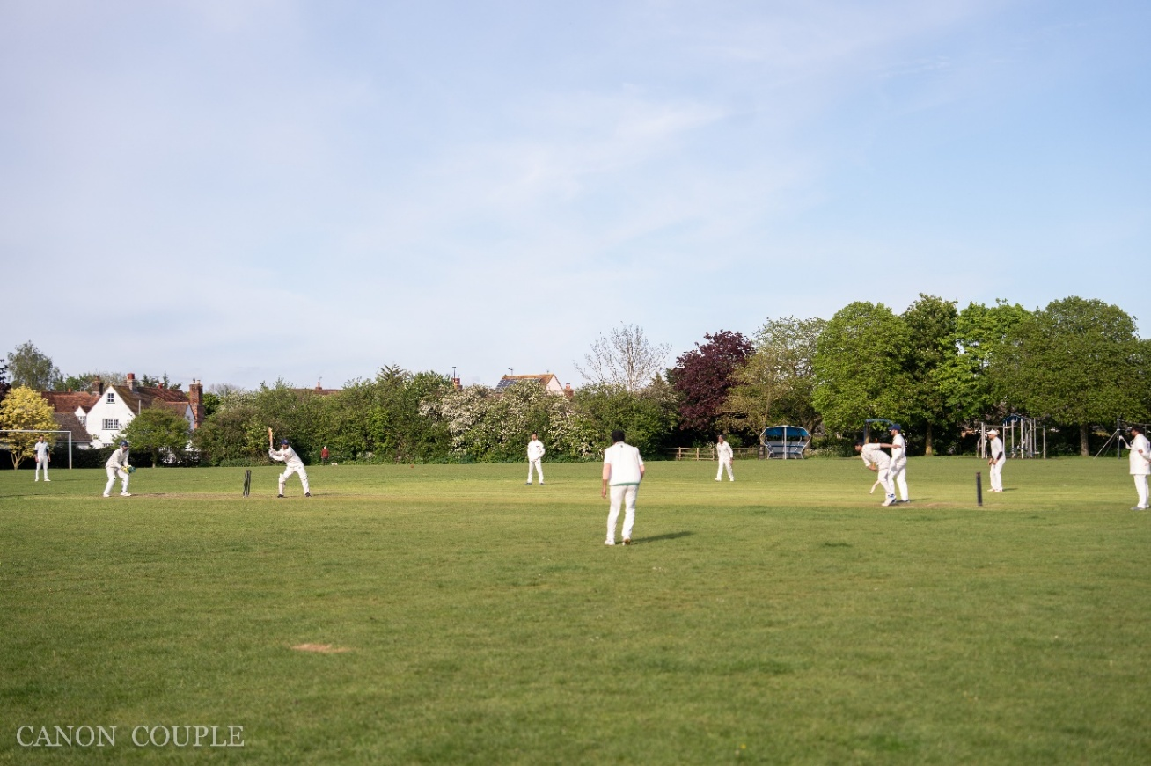
Figure 5.5 Boreham Royals cricket team playing on the John Galley Memorial Ground (photo courtesy of the Boreham Royals cricket club secretary)
In its strategic policy S4 of the CLP, CCC seeks to minimise the loss of the best and most versatile (BMV) agricultural land (Grades 1, 2 and 3a) to major new development. Much of the land around Boreham is (BMV) farmland comprising land in Agricultural Land Classification (ALC) grades 2, 3a, in addition to grade 3b (Refer to Figure 5.4). Local Plan Policy DM8 sets out some exceptions to development in the rural area, and Para 3.29, 5.32. The need for food production on good quality agricultural land has increased since the CLP was ratified due to the impacts of the war in Ukraine. This justifies stronger measures to protect the good quality farmland around Boreham.
The reasons why the Chelmer Valley should be protected are set out in the evidence paper titled EB3: Chelmer Valley Landscape Character. In summary, the Chelmer Valley forms the whole of the southern part of the Parish and provides the physical and visual setting for the nucleated village of Boreham. Accordingly, it is of considerable significance to the future of the Parish, not least in maintaining its character as a village in a rural setting with a clear separation from the urban are of Chelmsford to the west and the nucleated village of Hatfield Peverel to the north-east.

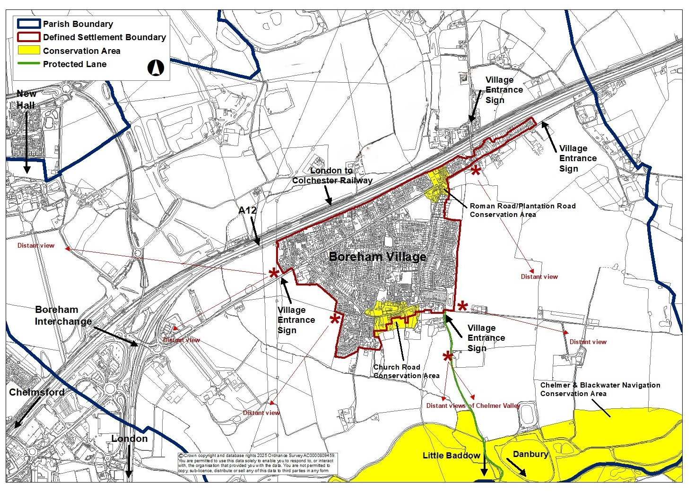
Figure 5.6 Outline Map showing the long views from Boreham which should be protected.

5.3 Built Environment Policies

5.3.1 Defined Settlement Boundary
Key Issues:
The Defined Settlement Boundary for Boreham is shown in Figure 5.7. It was amended in May 2020 (Chelmsford 2022 Local Plan) to incorporate the recent Orchard Way Development and housing to the east of the village on Main Road. The development at Orchard Way included 147 dwellings including several affordable housing units. This development fulfilled the obligations on Boreham under the 2022 through to 2035 Local Plan. The development includes a play area for young children but does not include any other community infrastructure.
As can be seen from the map in Figure 5.7, the Defined Settlement Boundary of Boreham Village continues to be separated from Chelmsford, Springfield, Beaulieu, by open fields although, in some cases, the separation is small. This is also the case with neighbouring villages of Hatfield Peverel and Little Baddow.
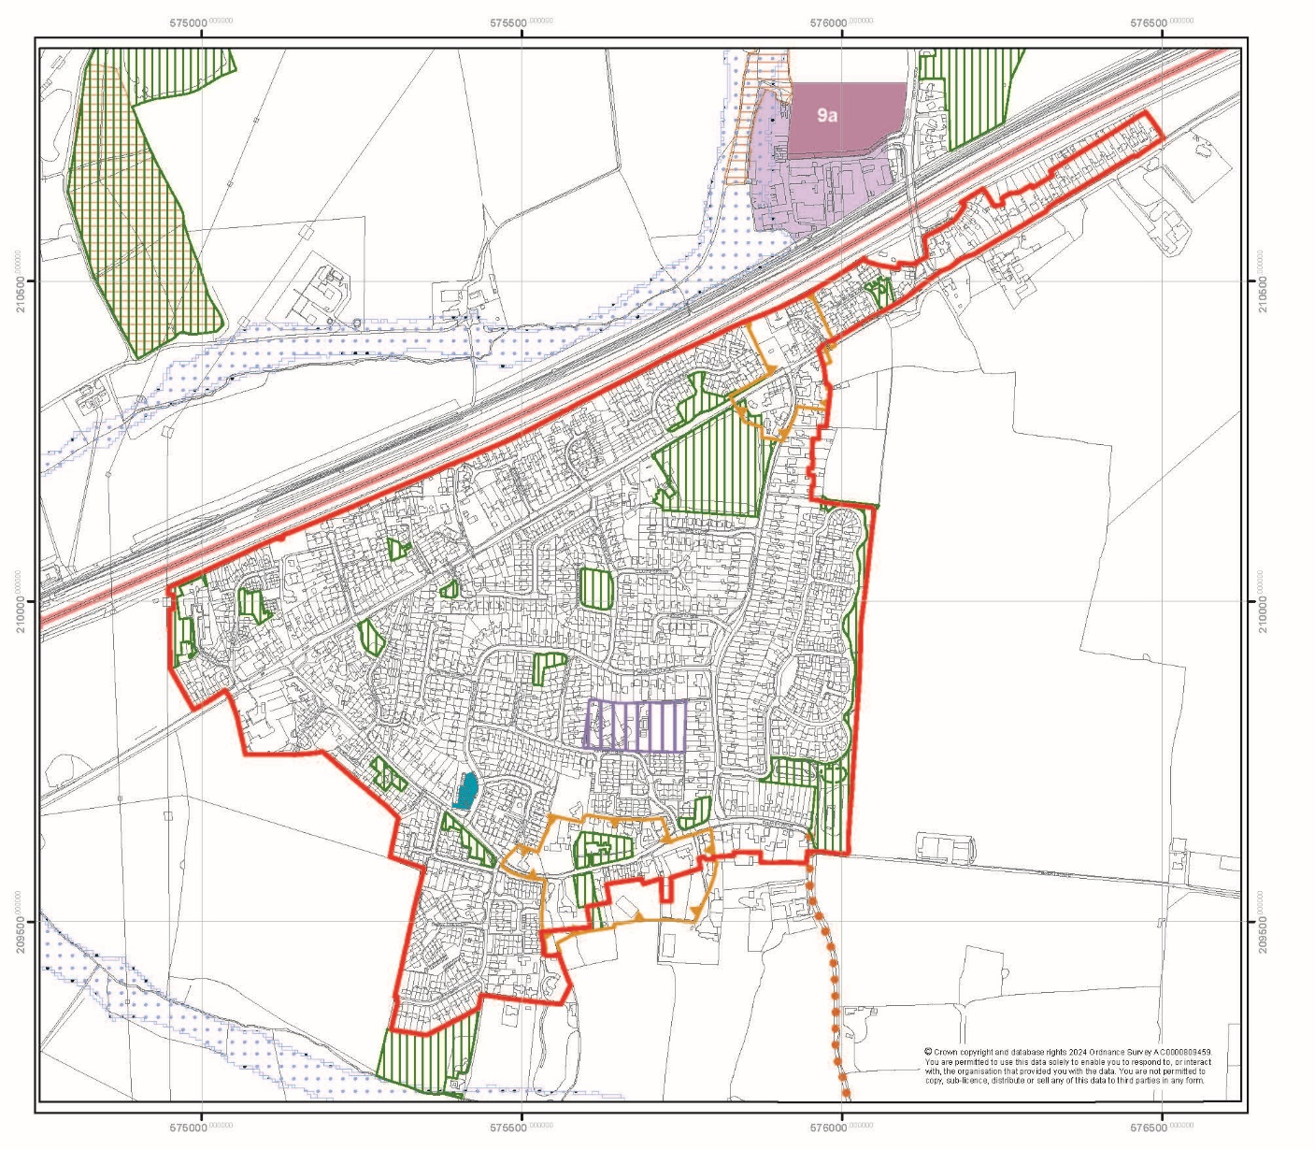
Figure 5.7 Boreham Defined Settlement Boundary
Objectives:
It has been the strong desire of the residents of Boreham for it to remain a village and to avoid coalescence with neighbouring communities. This was confirmed in the Questionnaire responses. The avoidance of coalescence, particularly with the built up area of Chelmsford is a key issue for Boreham, and is discussed in the EB4: Coalescence Assessment Report (prepared by DAC Planning Ltd) in the Evidence Base. In order to prevent coalescence, the protection of undeveloped areas of countryside on the edges of Boreham, particularly to the north, south and west, which provide separation is essential. These undeveloped areas of countryside are incorporated into the Coalescence Safeguarding Zone identified in the DAC report. The proposed coalescence safeguarding zone is set out in Figure 5.9.
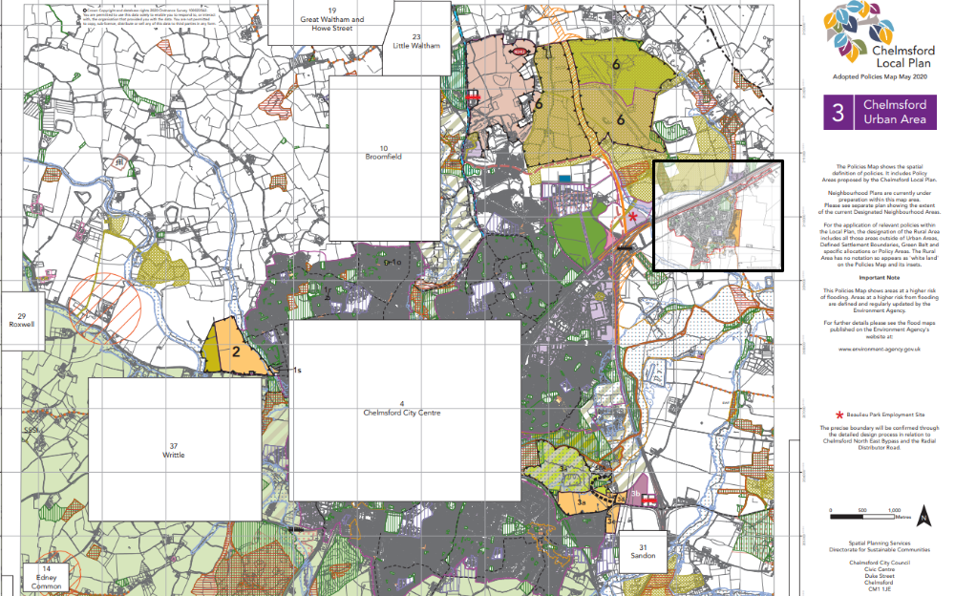
Figure 5.8 Chelmsford Urban Area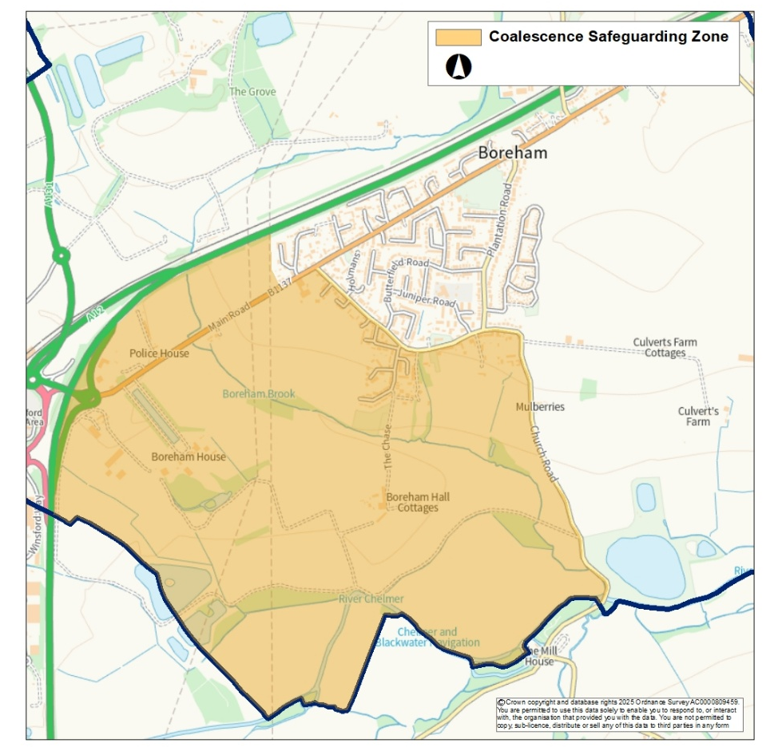
Figure 5.9 Map showing the coalescence safeguarding zone for Boreham
This policy will support Objective 1.

Policy 4 Settlement Boundary
- Development proposals within the Defined Settlement Boundary identified in Figure 5.7 will be supported where they meet the aims of sustainable development and the requirements set out in other policies of the Boreham Neighbourhood Plan and the Chelmsford Local Plan.
- Major Development of new buildings outside the Defined Settlement Boundary will only be supported where it is demonstrated that it meets a specific need within the village and it is accompanied by the relevant infrastructure and services.
- Residential development outside the Defined Settlement Boundary or the Coalescence Safeguarding Zone should be located adjacent to the existing settlement, be sympathetic to the character of the open countryside and have minimal visual and environmental impact and make use of previously developed land and existing buildings wherever possible.
- Development proposals within the Coalescence Safeguarding Zone identified in Figure 5.9 will be supported which:
  - Demonstrate how the proposal safeguards the open character of the setting of Boreham village , and where appropriate provides a visual impact assessment, clearly demonstrating the impact of development on the character and appearance of Boreham village and the Coalescence Safeguarding Zone, and outlining proposed mitigation measures; and
  - Maintain the separate identity of Boreham village and do not, individually or cumulatively, result in coalescence with neighbouring settlements; and
  - Where possible make use of previously developed land and existing buildings; and
  - Are of a scale and visual appearance that will not detrimentally impact on the character and appearance of Boreham parish; or
  - are the subject of an allocation in the Chelmsford Local Plan.

Justification:
The avoidance of coalescence is an essential factor in maintaining the character of Boreham as a separate village in a rural setting. The Orchard Way development meets the requirements for additional housing in Boreham as set out in the Chelmsford 2022 Local Plan. The Defined Settlement Boundary has been adjusted to include this completed development and should now be maintained.
In 2024, the Boreham Parish boundary was redrawn with a significant portion removed and allocated to the new Parish of the Chelmsford Garden Community, which will be developed to accommodate 10,000 new homes and include 45,000 sqm of new employment opportunities. The total of which more than fulfils Boreham’s contribution to development in Chelmsford.

5.3.2 High Quality Design
Key Issues:
The growth of Boreham has resulted in a number of estate type developments that have, in some cases, detracted from traditional buildings in the village and the three local conservation areas. New development within the existing Defined Settlement Boundary provides an opportunity to integrate new buildings with more established sites in Boreham and improve the aesthetics and functionality of housing for village residents.

Objectives:
New development should seek to create high-quality places through a design-led approach to development, underpinned by good practice principles and reflecting a thorough site appraisal. Development proposals should have regard to guidance and best practice principles established in the Essex Design Guide, the CCC’s Local Plan Making Places SPD and relevant other codes. Applicant must demonstrate how they will maintain particular character areas within the village where certain treatments are more appropriate, such as low brick wall boundaries in Church Road, retention of open frontages in Plantation Road and St Andrew’s Road and hence maintain the character of other roads around.

Policy 5 High Quality Design

- As appropriate, all new development shall:
- Add to or maintain the rural nature, character, and appearance of the Parish; and
- Retain existing trees and green spaces that support the character of the area; and
- Complement the existing street scene; and
- Provide adequate parking having regard to the Essex Parking Guidance as prepared by the Essex Planning Officers’ Association, appropriately screened where possible; and

- Scale development appropriately to minimise intrusion on neighbouring residential properties and surrounding areas.
- As appropriate, all new major development (as defined in the Glossary to the NPPF) shall:
- Create well designed and easily accessible places to live that respect distinct local details such as for materials, boundary treatments, building heights, street scene etc.; and
- Create safe places that allow for natural surveillance of surrounding routes with overlooking active frontages; and
- Incorporate sustainable design features which promote water efficiency, energy conservation and efficiency and support renewable energy and low carbon energy generation; and
- Provide a development density that is consistent with the character and appearance of existing development in the immediate surrounding area; and
- For residential development only, provide adequate multifunctional green space for play and wildlife benefits.

Justification:
Good design is not just a matter of appearance, but also about the functionality of the development and its relationship to its surroundings. Good design is not about imitating past styles or preventing innovative modern design. The aim is to create a site-specific and creative design, which responds to the form and the locally distinctive materials of its surroundings but does not merely copy neighbouring buildings or their details. Good design is about creating sustainable settlements, which are integrated with their setting both functionally and aesthetically, integrating and enhancing important environmental features whilst contributing to overall Parish design quality. New development should have due regard to the density, scale, layout, appearance, architectural detailing, materials, and history of the surrounding area. This should reflect rural village type solutions (green spaces) rather than urbanised solutions (paved squares). Sustainable design features should include rainwater capture, good insulation and off grid energy where feasible.
This policy supports Objectives 12 and 13.

5.3.3 Housing Mix and Type

Key Issues:

In all new housing developments , when considered in total, there needs to be a mix of building types, sizes and tenures to accommodate all who want or need to live in Boreham.

Objectives:

Historically Boreham has been a sustainable community with housing needs fulfilled by responding to local need. In recent years local residents have commuted out of Boreham for work, many generations of families have retained their connection to the village. There are many examples of two and three generations of families living in Boreham. We need to ensure a housing mix in type, size and tenure for those who want or need to live in Boreham. New development should be well designed, accessible and inclusive for both buildings, play spaces and communal areas.
Mixed tenure is residential development, which combines a range of tenure options, which can include owner-occupier housing, shared ownership housing and rental properties (social and private) all provided to the same design standards. Part of the need to preserve this mix of residential properties is to secure the future of the Boreham Community from cradle to grave. This includes first time homemakers, family homes, and smaller homes for downsizing and sheltered accommodation. Possibly also allowing for provision of care homes.

It is important to recognise in assessing the housing mix that many homes are extended to provide additional space. Whilst this makes financial sense for owner-occupiers it does potentially remove the availability of smaller homes for first time occupants or those wanting to downsize. This also relates to the expansion or extension of existing bungalows which are suitable for older or less mobile residents. These practices make it more challenging to preserve the mix of residential properties.

We have not identified specific deficiency in housing for those who want or need to reside in Boreham during the drafting of this document. We have however received feedback through this process that more affordable smaller affordable homes should be provided.

Policy 6 Housing Mix and Type

- New housing development proposals within the Parish of Boreham shall demonstrate how the types of homes provided will contribute to a balanced mix of housing types to meet local needs and provide:
- A range of housing types, sizes, tenure and mix; and
- Tenure blind affordable housing which meets local needs; and
- Housing for older people and those with a disability, including bungalows and supported and sheltered housing.
2. On developments for less than 10 homes, proposals for smaller and/or mid-size dwellings (1 to 3 bedrooms) will be encouraged and preferred over the development of 4+ bedroom dwellings.
3. Development proposals which propose to apply a discount of 30% or greater on First Homes will be supported to meet the threshold on affordable homes.
4. Developments with bungalows of up to three bedrooms will be supported.

Justification:

The 2020 Boreham Neighbourhood Plan Questionnaire illustrates that there is a consensus amongst villagers for Affordable Housing to buy or rent, this would include both developer led provision, social housing but also sheltered accommodation for the elderly or infirm. Further, there was an emphasis on family homes. This identified a significant shortage of smaller properties having three or less bedrooms, which are within the reach of young people and families. The Questionnaire was undertaken prior to the completion of the 147 houses in Orchard Way.

The 2020 Boreham Neighbourhood Plan Questionnaire also highlighted the need to provide older peoples’ housing, including bungalows and supported and specialist sheltered housing in line with Supported Living accommodation standards. We support ECC strategic goal to enabling people to live independently throughout their life – housing that is designed to be accessible, adapted to become accessible to meet the changing needs of residents, especially as they age, and has support and care available for those who need it.
Density of new development must reflect the current built form of Boreham. Whilst the Local Plan will determine required densities these must be considered in relation to existing development and have the overall intent of maintaining the fundamental character of Boreham Village in a rural settlement.

5.4 Community Infrastructure and Developer Contributions Policy

Key Issues:
The term community infrastructure as used in this document encompasses multiple elements and services required to support the residents of Boreham. It includes early years and primary school capacity, local medical facilities, recreational facilities and necessary social and retail services. Since the completion of the development at Orchard Way and following the Covid pandemic, significant elements of the community infrastructure in the village of Boreham are operating at capacity.
A survey of early years and pre-school facilities in Boreham has shown that the availability of early years and childcare has declined whilst the demand has increased in recent years. Garden Cottage Nursery closed during the Covid Pandemic with a loss to the community of 30 pre-school places. Three childminders have also left the profession with a loss of further capacity. Boreham is currently served by Little Hedgehogs, one of very few local facilities accepting infants below the age of 2. Small Steps at the village hall, a pre-school for ages 2.5 to 4 years old, closed on 1st April 2025.
Primary school places are also limited within Boreham. Additional capacity has been created with the opening of Beaulieu Park Primary School and there are alternative primary schools within 5 miles of Boreham but Boreham parents have expressed a strong desire for pre-school and primary school aged children to be educated within our village.
In March 2023, the previous government set out plans to increase funded entitlements for working families. By September 2025, most working families will be able to access 30 hours of funded childcare each week (term-time) from the term after their child turns 9 months. This extension has led to the need for more early years and childcare places to be created across many wards, especially for children aged 0-3 to enable parents to return to work and take up their funded entitlement.
ECC has supported the opening of a new preschool in the former Garden Cottage Nursery premises which provides term-time places for children aged 2-4. An additional nursery provision opened in 2025 within the grounds of Boreham Primary school. Both of these provisions will help to meet the need for childcare places within the ward, although places are still in short supply.
Developer contributions is a collective term mainly used to refer to the Community Infrastructure Levy (CIL) which is a fixed charge levied on new development to fund infrastructure. Where the CIL is in place for an area, charging authorities should work proactively with developers to ensure they are clear about the relevant authority’s infrastructure needs and for Boreham, this will be informed by this BDNP. Chelmsford City Council is a CIL charging authority.
Developer contributions may also derive from Planning Obligations (commonly referred to as 'Section 106' or 'S106' obligations after Section 106 of the Planning Act). Developers may be asked to provide contributions for infrastructure in several ways and local authorities are required to consider whether otherwise unacceptable development could be made acceptable through the use of conditions or planning obligations. Such conditions should be limited to developments where it is not possible to address unacceptable impacts through a planning condition (and only imposed where they are necessary, relevant, enforceable, precise and reasonable). Developers must comply with conditions attached to their planning permission.
Funding from different routes can be pooled to fund the same infrastructure provided it is clear which infrastructure is to be funded. Plan makers should consider the combined total impact of such requests so they do not undermine the deliverability of the plan. This may not benefit Boreham specifically as a village.
Further information can be found at the CCC CIL resources on the website: https://www.chelmsford.gov.uk/planning-and-building-control/community-infrastructure-levy/. And at the Neighbourhood Allocation of CIL monies, Section 5 of this document: www.chelmsford.gov.uk/media/555mib1q/cil-governance-allocating-and-spending-cil-march-2024.pdf
Previous developments in Boreham have included play areas for young children which include swings, slides, climbing and other similar play equipment but has not provided other required infrastructure. The recent Orchard Way and Holmans Close developments are examples of this. Recreational facilities for older children and young adults are very limited in Boreham and this may be contributing to anti-social behaviour and outbreaks of vandalism. In the responses to the Questionnaire, 62% expressed the view that facilities for young people are not adequate. Addressing this is a priority for Boreham Parish Council.
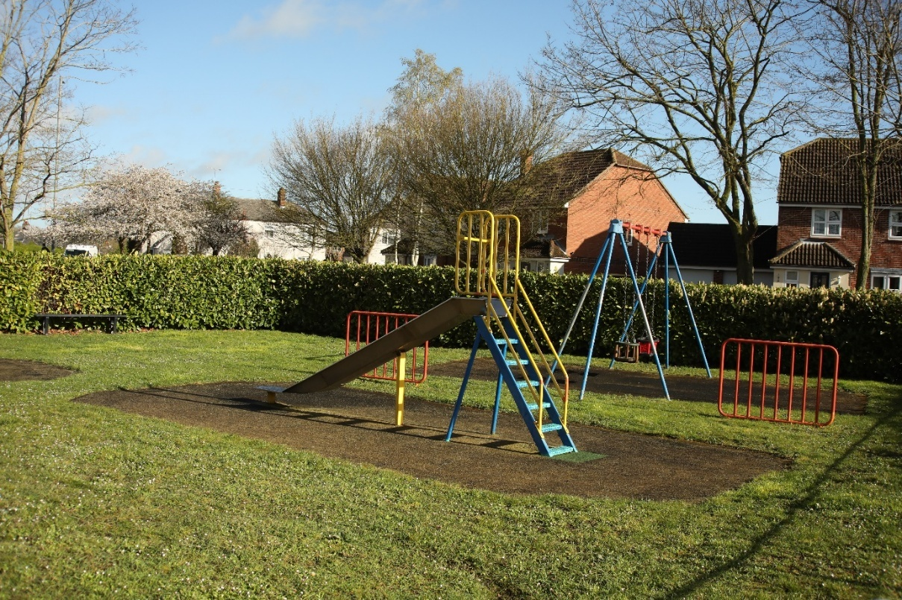
Figure 5.10 Play equipment at Holmans
In the absence of specific provisions for community infrastructure within a plan for development, then CIL money should be used to satisfy any additional need for infrastructure arising from the development.
Objectives:
Any new development should be part of a sustainable enhancement to the village and major development proposals (that is those of 10 or more dwellings, and/or development proposals on a site area of 1 hectare or more, or developments of any size outside the Defined Settlement Boundary), should contribute specifically to infrastructure that allows the Boreham Village community to survive and flourish.

This policy is also designed to ensure that the residents of Boreham benefit from developer contributions made to the Local Authority as they relate to development in the Parish of Boreham and/or that any potentially negative impacts of new development on the village infrastructure are addressed within the plans for any development and timely delivered. This policy supports Objectives 14,15 and 16.

Policy 7 Community Infrastructure and Developer Contributions

- As appropriate, all major development shall make contributions towards local infrastructure, services and facilities, including:
- Appropriate mitigation, compensation and enhancements to the local and strategic road network as required by the Local Highways and Transportation Authority
- Appropriate measures to promote and enhance active and sustainable modes of transport
- Financial contributions to early years, primary and secondary education together with Special Education Needs and Disabilities provision
- Financial contributions and/or onsite provision of community facilities including healthcare provision as required by the NHS Mid and South Essex Integrated Care Board
- Provide, or make financial contributions to new or enhanced sport, leisure and recreation facilities; and where a need is identified provide or make financial contributions for new small-scale businesses, particularly where they are well integrated with existing businesses, do not rely heavily on HGV traffic and reflect the local character.
- Where appropriate, in accordance with the CIL Regulations, developers should contribute towards the local infrastructure projects identified within Table 5.1.

Justification:
There is a regulatory framework for the provision of adequate access to school places and particularly for early years and childcare services. Paragraph 100 of the NPPF (December 2024 as updated 7 February 2025), reflects the importance the Government attaches to ensuring sufficient choice of school places to meet the needs of existing and new communities. Non-statutory guidance for local authorities for education to support housing growth and developers’ contributions is provided in the Department for Education publication – ‘Securing developer contributions for education,’ (November 2019). The Chelmsford Local Plan Strategic Policy S5 recognises that an important element of sustainable development is the provision and protection of community uses such as schools. Strategic Policies S9 and S10 set out the infrastructure required to support new development, including early years, primary, secondary and tertiary education provision and how to secure the infrastructure and mitigate impact.
The decline in early years places is not limited to Boreham. It also effects neighbouring villages. In Hatfield Peverel, an 80 place nursery closed during the Covid pandemic leaving Little Bears which caters for ages 2 to 4 years operating at capacity with a waiting list (as of 2023). A new nursery (Hatfield Peverel Nursery School) has opened at Hatfield Peverel Infant’s School, providing term time places for children aged 2-4 years which has provided more provision. Across Essex there is an overall capacity loss of approximately 35% of pre-school places (Essex Capacity Audit for ages 0-8). A consequence of the lack of pre-school places is the impact it is having on those receiving Funded Early Education Entitlement (FEEE). Many cannot access FEEE because of the lack of available spaces where it can be used and this is occurring in Boreham. The recent childcare sufficiency audit for 2024 shows that Hatfield Peverel ward was in high demand for early years, with less than 15% of places being available.
Primary school places are also limited within Boreham. Additional capacity has been created with the opening of Beaulieu Park Primary School and there are alternative primary schools within 5 miles of Boreham but Boreham parents have expressed a strong desire for pre-school and primary school aged children to be educated within our village. For school age children, the Boreham Primary School is operating classes for children from 4 (Early Years/ reception) to 11 years of age and all are usually full. Other children of these age groups are required to attend alternative primary schools outside the village incurring longer travel times and bus fare expense. Further major development within Boreham should include provision for extending the number of primary school places to accommodate additional young families and to reduce the need for primary school aged children to travel to schools outside the village.
The medical needs of Boreham are served by the Laurels Surgery GP practice and pharmacy. In the responses to the Questionnaire, 57% expressed the view that this surgery was not adequate to cover the needs of the community. In addition, there is a documented need in Boreham for additional park and recreational space and allotments.
Infrastructure Project | Source
Increased capacity for early years, Key Stage 1 and Key Stage 2 learning | See above
Provision of safe pedestrian access along Waltham Road to connect footpaths in the north of the Parish to the village of Boreham. | BNDP Policy 9 Sustainable Transport
Provide new and/or enhanced bus services, new and improved public transport infrastructure including but not limited to, real time information systems, sheltered waiting facilities and accessibility to services. | BNDP Policy 9 Sustainable Transport
Provision of:  - Parks and Recreation  - Natural and semi natural  - Allotments  To meet shortfalls | Chelmsford City Council Open Space Study December 2024 as it relates to Boreham Parish
Public footpaths, cycle paths and bridleways improvements and provision. | BNDP Policy 9 Sustainable Transport
Table 5.1 Local Infrastructure Projects which could benefit from developer contributions

5.5 Broadband and Communication
Key Issues:
Work habits are changing since the Covid 19 pandemic. A higher percentage of villagers are working from home for part of the week, reducing the need to travel. This follows the national trend. In addition, the Boreham economy benefits from small local businesses and sole traders including those associated with the building and related trades, personal and professional services. The lack of fast and reliable broadband has been identified as a weakness for Boreham (SWOT analysis).
The NPPF states that ‘advanced, high quality and reliable communications infrastructure is essential for economic growth and social well-being’ (NPPF, December 2024 as updated 7 February 2025, paragraph 119).
The number of devices in use for work and leisure is increasing and a better broadband service is needed to support this. The increasing number of devices at each address includes mobile phones, PCs, laptops, tablets, smart watches, TVs, set-top boxes, games consoles, smart speakers, players, media streamers and even doorbells and security systems. Ofcom has identified strong growth in the adoption of Internet-enabled devices, with each household in the UK now having several different types of Internet-enabled device.
All these devices compete for the same limited bandwidth when they access the Internet or perform a software update and basic broadband services with slow speeds will increasingly become a major bottleneck to business, educational and non-business users.
Objectives:
We have an objective to improve broadband speeds within the parish of Boreham to support current and future service demands from the residents of our village (Objectives 17 and 18). This can be achieved by introducing gigabit speed superfast broadband to the village. We also have an objective retain, create and grow local employment opportunities which will not alter the nature of the parish as a rural community and it is our belief that such enterprises require adequate access to gigabit speed broadband and 5G mobile services if we are to protect the character and appearance of the village

Policy 8 Broadband and Communication

- As appropriate, proposals for new developments or expansion of existing properties shall include provision for receiving high speed and reliable mobile and broadband connectivity.

- The BNDP will support proposals to provide access to a gigabit speed super-fast broadband network to serve the village and other properties in the countryside. In doing so, it will require the location and design of any above-ground network installations to be sympathetically chosen and designed to reflect the character of the local area.

Justification:
The national UK Superfast Broadband Programme has been delivering faster broadband connections to premises with less than superfast (30Mbps) download speeds since 2011, and the national target of reaching 95% superfast broadband coverage across the UK was achieved in December 2017. The NPPF Chapter 10 (Supporting high quality communications infrastructure) with particular reference to Paragraphs 118 to 122 emphasises the need for advanced, high quality and reliable communications infrastructure to support economic growth and social well-being. It indicates that planning policies and decisions should support the expansion of electronic communications networks, including next generation mobile technology (such as 5G) and full fibre broadband connections and sets out guidance for achieving this.
Superfast Essex programme is aligned with this objective to deliver supporting infrastructure in collaboration with government, Essex districts and boroughs and commercial partners. The superfast broadband rollout has plans to reach 99% of all premises in Essex by 2023. The aim is to ensure that no individual or business is excluded from digital opportunities due to lack of high speed and affordable broadband connections, equipment, or skills. ECC published its Digital Strategy and action plan in June 2022 which seeks to ensure that by the end of 2025:
- Superfast speeds will be available at all premises in Essex
- Gigabit-capable services available at more than 85% of premises in Essex
- 4G services available at over 99% of the Essex geography
- 5G services available at all key employment locations and in identified priority areas
The programme seeks to ensure that new, faster services, delivered by gigabit-capable or 5G technology, reaches everyone in Essex.
Without gigabit speed superfast broadband in Boreham, we will not be able to support demand for service from businesses and those working from home and users of intensive content such as TV and video. Without superfast broadband, intensive content such as TV and video becomes increasingly restricted. Picture quality can be degraded and users can experience buffering.
Gigabit superfast broadband offers a wide range of benefits:
- It is more reliable than standard broadband - it suffers from fewer faults.
- Small local businesses can rely on superfast broadband for efficiency improvements and cost savings due to improved processes and access to cloud based services.
- With the dramatic rise in home or hybrid working, more businesses are relying on internet calls, such as Zoom and MS Teams. Superfast broadband provides substantially improved performance for these uses and for online gaming and voice and video telephony which are sensitive to time delay.
- It is better for many apps, such as browsing, online shopping, online banking and social media.
- It delivers bigger upload speeds, which speeds up online back-up and file sharing
- Some buyers view fast broadband as essential.
- Finally, it can be cheaper than standard broadband.
As touched on above, superfast broadband enables home working and can improve work-life balance. Standard broadband is unlikely to permit reliable access to business systems (for example, accessing a corporate network) or allow employees to communicate effectively and reliably with colleagues or customers through video conferencing. Superfast broadband enables many of the business processes, such as effective communications, that are critical to making home workers productive and (at least) as effective as they would be in traditional offices.

5.6 ACCESS AND MOVING AROUND

5.6.1 Sustainable Transport

Key Issues:
Boreham has a reasonable level of public transport with direct bus services along Main Road and also some services diverting around the village periphery route; Church Road and Plantation Road, re-joining Main Road again to continue onto further destinations. The detailed services are described in EB9 - Boreham Transport Evidence Base V2. There are many school transport buses that pick up students along stops in Main Road and also a limited number that pass around the loop Church Road/ Plantation Road. Most secondary students use these services daily. More recently, the number of buses through the village is being reduced and this has an impact on elderly users in particular.
Main Road is continuously trafficked by passing vehicles especially in the peak periods. The resulting transport artery is unsuitable for this location and effectively cuts the village in two. Many of the passing vehicles are HGVs, which can travel legally at 40mph. Pedestrians on the footways along Main Road are intimidated by the proximity of HGVs in particular and the associated buffeting and noise. It is also a deterrent to cyclists and other non-vehicle road users.
In the Questionnaire, 68% of respondents agreed that Boreham needs more dedicated cycle paths. 87% expressed the view that connectivity between footpaths and bridleways north and south of the A12/railway line needs to be improved.
As part of the A12 Widening Scheme there were plans to create a new pedestrian/cyclist/bridleway bridge over the A12 at Paynes Lane to aid access to the new proposed Beaulieu Railway Station. The new Beaulieu Railway Station will be a lengthy walk from the village but a short cycle ride. The A12 Scheme has now been cancelled by central government along with this footbridge. However there is a possibility that this A12 scheme may be re-instated in a future government transport programme.
There is a dedicated cycleway along the Main Road B1137 from the Lion Inn through the A12 Junction 19 and connecting into Springfield and Chelmsford. Parts of this cycle way are to a good safe standard but the start/end involves negotiating general vehicular traffic on roads, particularly at A12 Junction 19 where crossing of busy slip roads is necessary.
Bridleway provision for horse riders is limited. There are only disjointed sections of bridleway indicated on the OS map of the area (Refer to Appendix 2 – Public Rights of Way) that again will involve joining/leaving the section from roads.
There is no specific cycle provision within the village built up envelope, apart from the short section of the cycleway from the A12 Junction 19 that terminates at the junction with Church Road. There is no continuing cycle facility along Main Road. The traffic islands along Main Road give rise to serious conflict between cyclists and vehicles due to narrowing of traffic lanes at these locations.
Objectives:
“Active Travel” is defined as any mode of transport other than motor vehicles. This can include:
• Cycling
• Horse riding
• Walking
Sustainable travel also includes train, bus and other shared occupancy vehicles.
The Neighbourhood plan seeks to increase and improve the use of active travel in the village, both for transport and for recreation and to ensure that sustainable transport levels are maintained. In addition, it is essential that Boreham residents are able to access new rail services at Beaulieu Park Station via active travel. These objectives may be achieved by increasing access to cycle and bridle paths within the Defined Settlement Boundary and beyond.
There would be a significant benefit for cyclist safety if a cycle route extended the entire length of the village on Main Road. A dedicated cycle route would also be beneficial to walkers by removing cyclists from the pavements. In addition to the provision of new routes, the policy seeks to ensure that new developments cater for secure cycle storage.
This policy specifically supports Objectives 19, 20 and 21.

Policy 9 Sustainable Transport

- In accordance with ECC Developers’ Guide to Infrastructure Contributions, development proposals should where appropriate include Travel Plans.
- All development shall provide cycle parking on-site having regard to the standards set out in the Essex Parking Guidance as prepared by the Essex Planning Officers’ Association
- As appropriate, all major developments (as defined in the Glossary to the NPPF) shall provide the following:
- Safe, secure and well-designed cycle storage and cycle parking on site: and
- Connections to existing bridleways, walking and cycling facilities without reducing the capacity, safety and convenience of these routes.
- In major non-residential development, cyclists' changing facilities on site
- Financial contributions towards;
- New walking and cycling routes that are direct, safe and convenient to use for all ages and abilities; and
- New or improved public transport facilities; and
- Good quality access to public transport services.

Justification:
Pedestrian needs are generally adequately provided for within the Defined Settlement Boundary by footway provision and also dedicated public footpath links away from the roads. There is a signal controlled pedestrian crossing on Main Road opposite Boleyn Way which is well used for access to schools transport and other village facilities such as the recreation ground, shops, primary school, doctor’s surgery and pharmacy. There is a further uncontrolled pedestrian crossing near the junction with Church Road, which though well used is not ideally placed for people who wish to cross from the Villiers Place area. These people tend to take the more direct route and cross at the traffic island near the Lion Inn, which is not ideal due to insufficient island refuge width. Heavy traffic on Main Road and the current 40 mph speed limit act as a deterrent to walkers and cyclists and this is addressed in Policy 10 Main Road and other roads in Boreham below.
The provision of safe and secure cycle storage facilities in all the developments detailed in Policy 9 will also encourage active travel. This includes for single family occupancy private dwellings cycle storage on the plot that is easily accessed at ground level without having to carry the bicycle through the dwelling. In the case of multi occupancy buildings a communal facility on the plot will be required using the same principles regarding ease of use, security and weatherproofing. Movement triggered lighting would be desirable. There is an example of good quality cycle storage facilities at Boreham School. It is robust, weatherproof, has good all-round visibility for security.

Key Issues:
Boreham suffers from a disproportionate volume of through traffic attempting to avoid delays elsewhere on the local and trunk road network as well as local village generated traffic. Through traffic primarily affects Plantation Road, Church Road and Main Road. It is generated from capacity stress on the A12 trunk road at peak times and as the result of road traffic collision (RTC) delays causing traffic to divert to the local network. In addition some local county road network capacity stress causes drivers to divert to Plantation Road, Waltham Road and Boreham Road. This through traffic is creating air and noise pollution which, when combined with that from the nearby A12, is likely to breach recommended limits at points within Boreham village within the term of this BNDP without steps to prevent it.
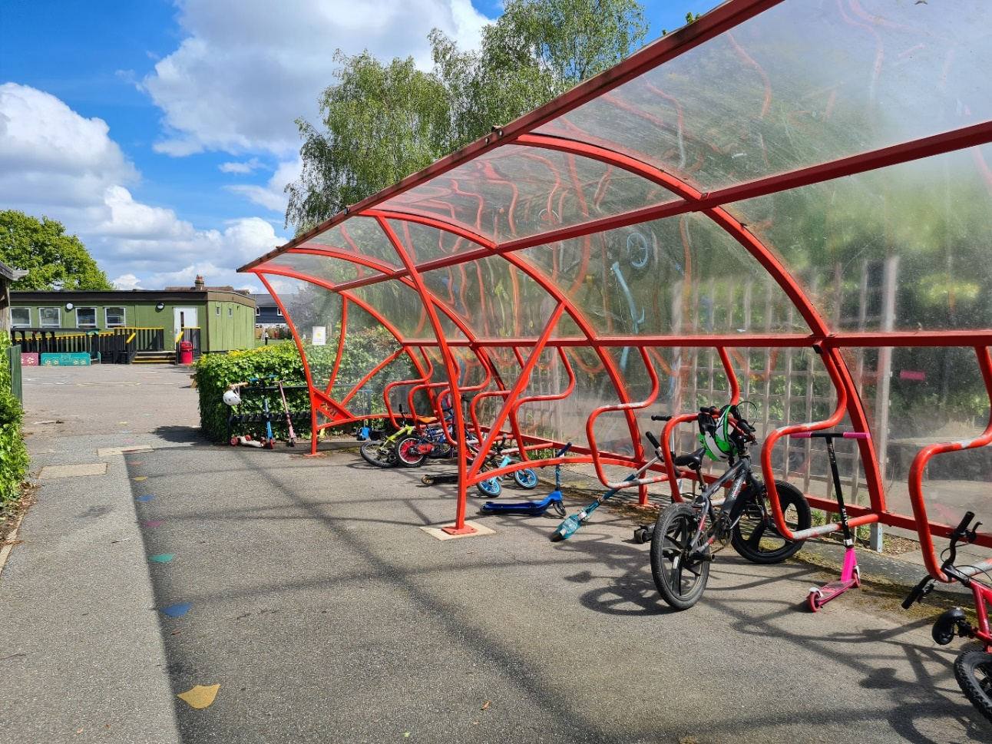
Figure 5.11 Boreham Primary School cycle and scooter storage facility

5.6.2 Main Road and other roads in Boreham
Until the opening of the A12 Springfield Boreham Bypass in 1971, Main Road was designated the A12 trunk road from London to Lowestoft/Great Yarmouth and in many places follows the line of the ancient Roman Road. It is this legacy that gives Main Road (B1137) its current appearance as a straight, wide road with high masted lighting and general facilities favouring road traffic. It also connects to the B1109 to/from Maldon in Hatfield Peverel and much of the motorised traffic using the road is through traffic, essentially, drivers wishing to get from A to B in the quickest time. Many drivers pay little regard to the road’s surroundings and the fact that it is passing through a village environment.
If there are delays on the A12, much of the trunk road traffic diverts to Main Road B1137. In addition, when A12 road closures are in place to facilitate road works on the trunk road mainly at night, all the trunk road traffic in one or both directions is deliberately diverted along B1137 Main Road causing much disturbance to residents. A proposed A12 Widening Scheme (Chelmsford to Marks Tey) has received development consent by the Secretary of State but was cancelled in a general government spending review in 2025 of national infrastructure projects. However, there is the possibility that this scheme will be re-instated within the life of this Plan. Development over the last 30 years in Boreham, due to previous land use, has been on the north-west side of Main Road. Residents who live on these developments wishing to travel on foot or bicycle have to cross Main Road to access local facilities taking in all the hazards associated with the traffic described above. There is housing on both sides of the road with a need for pedestrians to be able cross the road in safety. There are only two dedicated pedestrian crossings which are located where there is higher pedestrian movement but some diversion of the direct walking route is required in places, which is undesirable.
The construction of the Radial Relief Road around the Beaulieu Park and Channels Developments has done little to provide any relief from through traffic and reduce the necessity for drivers to divert to inappropriate minor roads such as Waltham Road. This through traffic problem may improve after the construction of the Chelmsford North-East Bypass. Through traffic causes unnecessary severance delays and extra air and noise pollution within the village. Any reduction in this extraneous traffic will reduce these issues. Future developments at the approved Chelmsford Garden Community and Hammonds Farm Garden Community (if approved for inclusion in the current 2025 review of the Chelmsford Local Plan) will inevitably increase traffic volumes on all four of the above mentioned roads.
Objectives:
Proposed developments must demonstrate that they will not adversely affect the current traffic, safety and severance effects along Main Road and other roads in Boreham. The objective is to reduce or mitigate traffic flow to increase safety and reduce air and noise pollution for residents. In addition to diverting through traffic, locally generated vehicular traffic from within the village should be reduced where possible either by local solutions within proposed developments or local village projects to discourage use of the private car. These should be explored with development proposals, either by CIL contribution funding or direct implementation of schemes. Traffic flow mitigation can be demonstrated in many ways for Main Road (a. to f.) and for Church Road/Plantation Road/Waltham Road (g.) as set out below:
  - More dedicated (signal controlled) pedestrian crossing facilities e.g. opposite the Co-Op.
  - Removal of existing narrow traffic islands and general narrowing of the whole carriageway throughout the Defined Settlement Boundary creating space for the installation of a dedicated cycleway through the village on the southwest side of Main Road.
  - Reduce the speed limit to 30mph plus average speed cameras to enforce the lower speed limit.
  - Mini roundabouts at Elm Road, Brick Kiln Road and Hurrell Down to calm the traffic. (Not Plantation Road/ Church Road or Waltham Road as this may increase rat running.)
  - Reduce the height of the street lighting to give the appearance of a village street and not a de-trunked through route.
  - Introduce very distinctive village gateways at each end of the village. This could include a very sharp deviation line for traffic with perhaps attractive flower beds within the deviation. Thus reducing vehicle speeds at the entrances to the village, giving the impression that drivers are entering a different, much reduced, highway standard and as such should drive accordingly.
  - Church Road/Plantation Road/ Waltham Road are more problematical in that pure traffic calming will be detrimental to the usage by residents of the village. Therefore, ideas should be explored remote from the built up area of the village to reduce traffic volumes on these roads.
This policy specifically supports Objectives 22 and 23.

Policy 10 Main Road and other roads in Boreham

- All developments having a significant effect on traffic volumes along Main Road shall include measures to improve connectivity across Main Road by employing means that may include:
- actively seeking ways to reduce/minimise through traffic on Main Road; and
- altering traffic flows and/or the nature of the traffic flow, in order to mitigate any direct adverse effects on Main Road; and
- providing on-site measures, or providing financial contributions, towards reducing the physical scale of Main Road by:
- Reducing the width of the carriageway and removing the central islands;
- Creating a dedicated cycle way to the south-east side to link up with the existing cycleway from the A12 Junction 19 (Boreham Interchange);
- Changing the street lighting regime by reducing the column heights to better reflect a village environment;
- Install traffic calming measures along the route within the Defined Settlement Boundary, such as mini roundabouts, pedestrian crossing facilities, lower the speed limit to 30mph.

- Development proposals shall endeavour to reduce through traffic and/or mitigate the effects of this traffic on Church Road/Plantation Road/Waltham Road. Any proposals are likely to be remote from the built up area of the village. Where developments are remote from the above roads but will inevitably affect traffic flows, then financial contributions will be sought towards mitigation works.

Justification:
In recent years attempts have been made to reduce the scale of Main Road in an attempt to calm the traffic. This has involved the provision of several traffic islands and road markings to give the appearance of narrower traffic lanes. These “calming” measures have had limited effect in slowing traffic and reducing the volume. Indeed in places, as previously described, at the traffic island locations, a positive hazard for cyclists has been created due to the narrow available road width shared with motorised vehicles. The recommendation to install a dedicated cycleway would effectively narrow Main Road carriageway to something more suitable for a minor (B) road through a village setting and would also support the objectives for active travel. Reduced height street lighting would strengthen the message that this is a village street.
Projects to deliver improvements for Main Road are actively being pursued by the Parish Council in association with Chelmsford City and Essex County Councils and projects of this nature could be funded via CIL contributions.
Many drivers ignore the 40mph speed limit, which in itself is too high for this location. The severance caused by the heavy traffic on Main Road has a detrimental effect on the village and can be a hazard to pedestrians. A lower, 30mph speed limit, if enforced, would make the route through Boreham less attractive and would reduce the risk to pedestrians and cyclists. In addition the volume of traffic using Main Road causes much disturbance to fronting and nearby properties by way of noise and air pollution and this would be reduced. This could be further assisted with mini roundabouts at key locations along Main Road.
Church Road/Plantation Road/Waltham Road are unsuitable for the traffic flows they experience, especially in the morning and evening peak periods. Waltham Road is a minor rural road, whilst Church Road and Plantation Road are peripheral roads with the purpose of feeding the built-up core of the village. Church Road has a conservation area in the area adjacent to St Andrews Church and a section of the road beyond the Defined Settlement Boundary is designated a protected lane while Plantation Road has a conservation area at its junction with Main Road. These roads currently serve two functions, (i) distribution of local traffic into/out of the core village and (ii) providing an alternative for through traffic to avoid problem areas remote from the village. These roads are only suitable for the first function.

ACTION PLAN

Table 6.1 Action Plan to be commenced after adoption of the BNDP

Action | Source
In Boreham, efforts of the local farming community, nature groups and developers need to be coordinated to create connected wildlife corridors which will enhance the impact on nature’s recovery and maintain or preferably improve on our present biodiversity | BNDP Policy 2 Biodiversity
Ensure a balance between the recreational use of environmental assets and environmental sensitivities in order to maintain wildlife diversity and minimise impact on nesting species.  This includes monitoring:  - recreational use and particularly unlicensed use or use during breeding/nesting seasons to understand and manage conflict.  - recreational use of footpaths, local water ways, lakes and the adjacent areas, including walking (with and without dogs), swimming, cycling, paddle boarding and canoeing.  - the potential for conflict with wildlife breeding (particularly disruptive to nesting waterfowl and ground nesting birds) and result in further decline in biodiversity. | BNDP Policy 2 and Policy 5 Recreational use of the environmental assets surrounding the village
Support and encourage Boreham community efforts to enhance biodiversity by:  - Increasing planting of flowers and shrubs that will attract insects to their gardens;  - Reducing the use of garden pesticides and herbicides;  - Setting aside a portion of gardens as wildlife areas;  - Encouraging species such as the endangered hedgehog and bats with links between gardens and addition of hedgehog and bat boxes  - Support and encourage local councils to manage road edge mowing and use of herbicides:  - Manage the cutting regime for roadside verges to enhance botanical diversity  - Review the use of herbicides within the parish, including those for path and road edges  - Support local farmers in their efforts to encourage biodiversity. This will be subject to eligibility for locally-specific and landscape-level support schemes through Local Nature Recovery and Landscape Recovery changes in legislation for farming and the environment. | BNDP Policy 2 Involvement of the village and wider community in enhancing biodiversity
To create a local list of non-designated heritage assets | Objective 2
Consider setting out initiatives to maintain the historic character of Boreham and celebrate the history of the village, making local history accessible to the community. | Objective 3

ABBREVIATIONS

ALC Agricultural Land Classification
BMV Best and most versatile (farmland) – ALC grades 1, 2 and 3a
BNDP Boreham Neighbourhood Development Plan
BPC Boreham Parish Council
BPHEC Boreham Parish Historic Environment Characterisation
CABE Commission for Architecture and the Built Environment
CBC Chelmsford Borough Council
CCC Chelmsford City Council
CIL Community Infrastructure Levy
CLP Chelmsford Local Plan
ECC Essex County Council
ERDL Essex Red Data List
HGV Heavy Goods Vehicle
LoWS Local Wildlife Sites
LP Chelmsford Local Plan
Mbps Megabytes per second
Mph Miles per hour
MS Microsoft
NE North Eastern
NP Neighbourhood Plan
NPPF National Planning Policy Framework
Ofcom Office of Communications
PC Personal Computer
PRoW Public Right of Way
RCCE Rural Community Council of Essex
RCLWS Register of Chelmsford Local Wildlife Sites
RTC Road Traffic Collision
SPD Supplementary Planning Document
TV Television
UK United Kingdom of Great Britain and Northern Ireland

APPENDIX 1 LISTED BUILDINGS IN BOREHAM PARISH

1. Grade II 1 and 2, McMillan's Cottages
2. Grade II 1, 2 and 3, Maltings Cottages
3. Grade II Babylon
4. Grade II Barn About 850 Metres East North East of New Hall
5. Grade II Barn at Bulls Lodge
6. Grade II Barn North East of Old Hall
7. Grade II Birds Farmhouse
8. Grade I Boreham House
9. Grade II Boreham Lodge
10. Grade II Boreham Manor North and Boreham Manor South
11. Grade II Brent Hall
12. Grade II Bulls Lodge
13. Grade II Caynton
14. Grade I Church of St Andrew
15. Grade II Clock House and Clock House Cottage.
16. Grade II Coppers and Ebenezer Cottage
17. Grade II Generals
18. Grade II Great Holts Farmhouse
19. Grade II Little Baddow Lock, Including Lock Gates and Four Bollards to Each Tow Path, Chelmer and Blackwater
20. Grade II Little Holts
21. Grade II Mount Maskells
22. Grade I New Hall
23. Grade II Old Hall
24. Grade II Shottesbrook
25. Grade II Six Bells Public House
26. Grade II Stonhams Lock, Including Lock Gates and Bollards, Chelmer and Blackwater Navigation
27. Grade II The Chestnuts
28. Grade II The Cock Inn
29. Grade II The Ginn House to the South East of Brent Hall
30. Grade II The Old Rectory
31. Grade II The Old Vicarage
32. Grade II Johnsons Barbers, Main Road (formerly The Wine Barrel)
33. Grade II Wallaces Farmhouse

APPENDIX 2 PUBLIC RIGHTS OF WAY
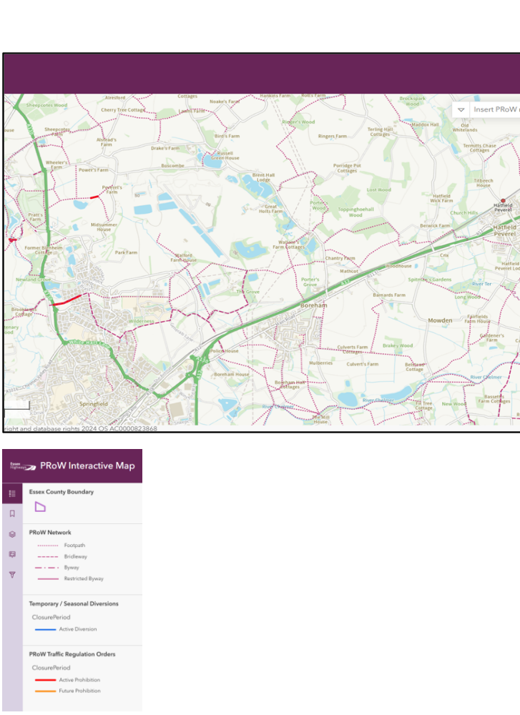
The above map and key are extracted from the Essex Highways Interactive map PRoW Interactive Map (arcgis.com)

APPENDIX 3 SUGGESTED PLANT LIST FOR DEVELOPERS

The following lists include native British and other trees and shrubs known to grow well in the Boreham area and to provide food and habitat for local wildlife species. Drought tolerant varieties are marked DT.
Trees
Alder (Alnus glutinosa)
Beech (Fagus sylvatica)
Birch, silver (Betula pendula) DT
Bird Cherry (Prunus padus)
Crab Apple (Malus sylvestris) DT
Field Maple (Acer campestre) DT
Hawthorn (Crataegus monogyna) DT
Hazel (Corylus avellana)
Holly (Ilex aquifolium)
Hornbeam (Carpinus betulus)
Juniper (Juniperus communis) DT
Lime, large leaved (Tilia platyphyllos)
Lime, small leaved (Tilia cordata)
Oak, common English (Quercus robur)
Oak, sessile (Quercus petraea)
Rowan (Sorbus aucuparia) DT
Sweet Chestnut (Castanea sativa)
Walnut, common (Juglans regia)
Whitebeam ((Sorbus aria)
Wild Cherry (Prunus avium)
Willow, goat (Salix caprea)
Hedgerow/Shrubs
Beech (Fagus sylvatica)
Bird cherry (Prunus padus)
Blackthorn (Prunus spinosa)
Dog rose (Rosa canina)
Dogwood (Cornus sanguinea)
Elder (Sambucus nigra)
Guelder Rose (Viburnum opulus)
Hawthorn (Crataegus monogyna) (DT)
Hazel (Corylus avellana)
Hornbeam (Carpinus betulus)
Spindle (Euonymus europaeus)

APPENDIX 4 LIST OF EVIDENCE BASE DOCUMENTS

Evidence Base 1 (EB1) - Boreham Parish Historic Environment Characterisation
Evidence Base 2 (EB2) – Boreham Natural Environment
Evidence Base 3 (EB3) - Chelmer Valley Landscape Character
Evidence Base 4 (EB4) - Coalescence Assessment Report from DAC
Evidence Base 5 (EB5) - Boreham Protected Lanes V2
Evidence Base 6 (EB6) - Boreham Community and Leisure
Evidence Base 7 (EB7) Built Environment Evidence Base
Evidence Base 8 (EB8) - Boreham Business and Local Economy V2
Evidence Base 9 (EB9) - Boreham Transport V2
Evidence Base 10 (EB10) - SEAHRA Screening Opinion from Chelmsford City Council

Acknowledgements
Thanks to all volunteers who gave their time to serve as members of the Boreham Neighbourhood Development Plan Steering Group since the start of this process.
We are grateful to Graham Ekins and Mark Hansen for their contributions to the Boreham Natural Environment Evidence Base.
Thanks to Graham Ekins for providing many of the photographs of our village.

https://www.gov.uk/government/publications/national-planning-policy-framework--2
https://www.chelmsford.gov.uk/planning-and-building-control/planning-policy-and-local-plan/adopted-local-plan/
Planning Practice Guidance http://planningguidance.planningportal.gov.uk/blog/guidance/neighbourhood-planning/what-is-neighbourhood-planning/
https://www.chelmsford.gov.uk/media/hdragpza/eb-144-essex-minerals-local-plan.pdf
https://www.southend.gov.uk/downloads/file/5194/adopted_waste_local_plan
https://www.gov.uk/government/publications/national-planning-policy-framework--2
https://boreham-np.org.uk/wp-content/uploads/2021/03/200220-Questionnaire-RESULTS.pdf
https://boreham-np.org.uk/links/
https://boreham-np.org.uk/links/
https://boreham-np.org.uk/links/
https://boreham-np.org.uk/links/
www.chelmsford.gov.uk/media/kprdaf1u/bg003-b-open-space-study-december-2024.pdf
www.chelmsford.gov.uk/media/aghbsdxk/inf005-chelmsford-city-council-idp-stage-2-report-november-2024.pdf
https://boreham-np.org.uk/links/
https://boreham-np.org.uk/links/
https://boreham-np.org.uk/links/
https://boreham-np.org.uk/links/
https://www.gov.uk/government/publications/national-planning-policy-framework--2
https://boreham-np.org.uk/links/
(Earth.Org)
https://boreham-np.org.uk/links/
https://boreham-np.org.uk/wp-content/uploads/2021/03/200220-Questionnaire-RESULTS.pdf
https://essexnaturepartnership.com/wp-content/uploads/2025/08/lnrs-jul-25.pdf
https://www.chelmsford.gov.uk/planning-and-building-control/planning-policy-and-local-plan/adopted-local-plan/
https://boreham-np.org.uk/wp-content/uploads/2021/03/200220-Questionnaire-RESULTS.pdf
https://publications.parliament.uk/pa/cm201012/cmselect/cmenvfru/writev/whitepaper/m44.htm
https://www.legislation.gov.uk/ukpga/2021/30/contents
https://boreham-np.org.uk/links/
Biodiversity net gain: exempt developments - GOV.UK
https://www.chelmsford.gov.uk/planning-and-building-control/planning-policy-and-local-plan/adopted-local-plan/
https://boreham-np.org.uk/links/
https://www.chelmsford.gov.uk/planning-and-building-control/planning-policy-and-local-plan/adopted-local-plan/
https://boreham-np.org.uk/wp-content/uploads/2021/03/200220-Questionnaire-RESULTS.pdf
https://boreham-np.org.uk/links/
https://www.essexdesignguide.co.uk/
https://www.chelmsford.gov.uk/media/pzofy3ef/making-places-supplementary-planning-document.pdf
2024 Essex Parking Guidance | Essex Design Guide
https://www.gov.uk/government/publications/national-planning-policy-framework--2
https://boreham-np.org.uk/wp-content/uploads/2021/03/200220-Questionnaire-RESULTS.pdf
https://boreham-np.org.uk/wp-content/uploads/2021/03/200220-Questionnaire-RESULTS.pdf
https://www.gov.uk/government/publications/national-planning-policy-framework--2
https://boreham-np.org.uk/wp-content/uploads/2021/03/200220-Questionnaire-RESULTS.pdf
https://assets.publishing.service.gov.uk/media/67aafe8f3b41f783cca46251/NPPF_December_2024.pdf
https://www.gov.uk/government/publications/national-planning-policy-framework--2
https://boreham-np.org.uk/links/
https://boreham-np.org.uk/wp-content/uploads/2021/03/200220-Questionnaire-RESULTS.pdf
https://www.essex.gov.uk/sites/default/files/2025-04/updated%20draft%20version%20of%20the%20%20Developers%20Guide%20to%20Infrastructure%20Contributions%20-%20April%202025.pdf
https://www.essexdesignguide.co.uk/design-details/2024-essex-parking-guidance/
https://www.gov.uk/government/publications/national-planning-policy-framework--2
Woodland Trust

